

Management & Science University

University Drive, Off Persiaran Olahraga

Section 13, 40100 Shah Alam

Selangor Darul Ehsan

**THESIS MANAGEMENT & EVALUATION SYSTEM**

(THEMES)

USER MANUAL for SUPERVISOR / CO-SUPERVISOR

Version 1.0

Document Reference: MSU/THEMES/UM/003

**DOCUMENT DETAILS**

|  |  |
| --- | --- |
| **Effective Date:** | 1 Jun 2015 |
| **Document Owner:** | Information Technology and Innovation Centre (ITIC) |

**REVISION HISTORY**

|  |  |  |  |
| --- | --- | --- | --- |
| **Date** | **Version** | **Description** | **Author** |
| 18 Feb 2015 | 0.1 | Document creation | Zuraimi, Amalina |
| 02 Mar 2015 | 0.2 | Document review and update | Zuraimi |
| 19 May 2015 | 1.0 | Final | Zuraimi , Nizam |

**TABLE OF CONTENTS**

1 INTRODUCTION 1

1.1 Scope 1

2 MODULE and FEATURE 2

2.1 Available Module and Feature 2

2.2 System Requirement 1

2.2.1 URL 1

2.2.2 Internet Browser 1

2.2.3 User Access 1

2.3 Screen Design 1

3 HIGHLEVEL FLOW 3

3.1 Thesis Proposal Submission Process Flow 3

3.2 Defence Proposal Process Flow 3

3.3 Work Completion Process Flow 5

3.4 VIVA Evaluation Process Flow 6

4 MAIN 7

4.1 Announcement 7

5 LOGIN and LOGOUT 8

5.1 Login 8

5.2 Logout 9

6 THESIS 11

6.1 Student Profile 11

6.1.1 Student Profile 12

6.1.2 Supervisor/Co-Supervisor List 13

6.1.3 Subject Taken 14

6.1.4 Thesis History 15

6.2 Thesis Profile 16

6.2.1 Student Profile Details 17

6.2.2 Supervisor/Co-Supervisor List 18

6.2.3 Subject Taken 19

6.2.4 Thesis History 20

7 Monthly Progress Report 21

7.1 Review Progress Report 21

7.1.1 Update Progress Report 21

7.1.2 View Progress Report 23

7.2 Progress Report History 25

7.3 List Monthly Progress Report 28

8 Proposal Defence 30

8.1 Review Defence Proposal 30

8.1.1 Update Defence Proposal 30

8.1.1 View Defence Proposal 32

8.2 Defence Proposal History 33

9 Work Completion - NOK 35

9.1 Review Work Completion 35

9.2 Work Completion History 35

9.3 Review Amendmen 35

10 Thesis Evaluation / VIVA 36

10.1 Review Thesis for VIVA 36

10.1.1 Review Thesis 36

10.2 VIVA Evaluation 42

10.2.1 Viva Evaluation 42

10.3 Review Amendment on Thesis 45

10.3.1 Review Feedback from External Examiner 45

10.3.2 Review Amendment on Thesis 47

11 Administration 52

11.1 Staff Biodata 52

11.2 Recommend Evaluation Schedule 53

11.2.1 Recommend Evaluation Schedule 53

11.2.2 Cancel Evaluation Schedule 54

11.3 Accept Invitation 55

11.3.1 Supervisor/Co-Supervisor 55

11.3.2 Evaluation Panel 57

11.4 Reviewer Feedback - NOK 59

11.4.1 Enter Feedback 60

11.4.2 Thesis Detail 60

11.4.3 Submit Feedback 61

12 Message 62

12.1 Inbox 62

12.1.1 New and Read Message 62

12.1.2 Delete Message 63

12.2 New Message 64

12.2.1 Send Message 64

12.2.2 Select Recipient 65

12.2.3 Upload Attachment - Add 67

12.2.4 Upload Attachment - Update 69

12.2.5 Upload Attachment - Delete 70

12.3 Sent Message 71

12.3.1 View Sent Message 71

12.3.2 Delete Sent Message 72

13 Control Panel 73

13.1 Change Password 73

13.1.1 Before Login 73

13.1.2 After Login 75

14 Help 77

14.1 Online Help - Student 77

14.2 User Manual 80

14.3 Frequently Asked Question 81

14.4 About Us 82

**LIST OF FIGURES**

Figure 1: Manual Structure 1

Figure 7: Modules and Features 3

Figure 2: THEMES Screen Structure Design 2

Figure 3: Thesis Proposal Submission Process Flow 3

Figure 4: Defence Proposal Submission Process Flow 4

Figure 5: Work Completion Process Flow 5

Figure 6: VIVA Evaluation Process Flow 6

Figure 8: Announcement 7

Figure 9: Login Page 8

Figure 10: Logout Page 9

Figure 12: Thesis Tab 11

Figure 13: Student Profile Tab 12

Figure 14: List of Supervisor / Co-Supervisor 13

Figure 15: Subject Taken 14

Figure 16: Thesis Tab – Thesis History 15

Figure 17: Thesis Tab – List of Student 16

Figure 18: Thesis Tab – Student Profile 17

Figure 19: Thesis Tab - List of Supervisor / Co-Supervisor 18

Figure 20: Thesis Tab - Subject Taken 19

Figure 21: Thesis Tab – Thesis History 20

Figure 21: Update Defence Proposal 21

Figure 21: View Defence Proposal 24

Figure 21: List Monthly Progress Report 26

Figure 45: Review Thesis 29

Figure 46: Review Thesis 30

Figure 47: Review Thesis 30

Figure 48: Review Thesis 31

Figure 49: Upload Attachment 32

Figure 50: Upload Attachment 32

Figure 51: Upload Attachment 33

Figure 52: Upload Attachment 33

Figure 53: Upload Attachment 34

Figure 54: Upload Attachment 34

Figure 55: Indicate number of attachment uploaded 34

Figure 56: Review Thesis 35

Figure 57: Review Thesis 36

Figure 58: Review Thesis 36

Figure 59: Review Thesis 37

Figure 60: Review Thesis 37

Figure 61: Review Feedback from External Examiner 38

Figure 62: Review Feedback of External Examiner 39

Figure 63: Review Feedback of External Examiner 39

Figure 64: Review Amendment on Thesis 40

Figure 65: Review Amendment on Thesis 41

Figure 66: Review Amendment on Thesis 41

Figure 67: Upload Attachment 42

Figure 68: Upload Attachment 42

Figure 69: Upload Attachment 43

Figure 70: Upload Attachment 43

Figure 71: Upload Attachment 44

Figure 72: Upload Attachment 44

Figure 73: Indicate number of attachment uploaded 44

Figure 17: Supervisor Biodata 45

Figure 18: Attachment to Supervisor Biodata 45

Figure 19: Invitation Acceptance 46

Figure 20: Invitation Acceptance - Remark 47

Figure 21: Outline of Resarch/Case Study 48

Figure 22: Accept/Reject Invitation 49

Figure 23: Reviewer Feedback 50

Figure 24: Enter Feedback 51

Figure 25: Thesis Detail 52

Figure 26: Feedback Submission 52

Figure 39: Message 53

Figure 40: Delete Message 54

Figure 41: New Message 55

Figure 42: Select Recipient 57

Figure 43: Upload Attachment - Add 59

Figure 44: Upload Attachment - Update 60

Figure 45: Upload Attachment - Delete 61

Figure 46: View Sent Message 62

Figure 47: Delete Sent Message 63

Figure 48: Change Password Page Before Login 65

Figure 49: Change Password Page After Login 66

Figure 58: Online Help 69

Figure 59: User Manual 71

Figure 60: FAQ 72

# INTRODUCTION

Thesis Management and Evaluation System (THEMES) version 1.0.0 is a system for the Student, Supervisor, Faculty and Senate to monitor the status of thesis proposal from its initial stage toward to the end. It is not only use by the respective personnel to control and manage the quality of the thesis to meet the university standard but it also can be used to keep track all the communication between the student and university. If required the history can be retrieved to view the completed work or its progress.

The system contains the main modules which are Thesis Proposal Submission and Approval, Monthly Progress Report Review, Thesis Proposal Defense, Thesis Work Completion, Thesis Evaluation/Viva and Senate Endorsement.

## Scope

The manual will guide the student on how to use the system in every stages starting from the thesis proposal submission, monthly report submission, defence proposal submission, work completion submission, viva evaluation and senate endorsement.

The manual is structured into the following sections:

| **Manual Section** | **Description** |
| --- | --- |
| Prerequisite | This section describes the actions or steps shall be done and in place first before the required steps can be done. |
| Steps | This section describes the steps to follow in order to yield the result for the desired function. |
| Next Action | This section describes the expected next steps to be followed once the above steps have been successfully performed. |
| Warning | This section describes the expected warning triggered by the system if the steps performed violate the business rule validation. |
| Note | This section describes the additional information which may be useful to the user while using the system. |

Figure 1: Manual Structure

# MODULE and FEATURE

## Available Module and Feature

The user will have the access to all the modules as listed below:

| **Module** | **Feature** | **Description** |
| --- | --- | --- |
| Main | Announcement | List of announcement published by the Faculty to announce important event or information to the student |
| Thesis | Thesis Profile | Retrieve a list of the postgraduate student which has been submitted the thesis proposal by searching their Thesis ID or Title. |
|  | Student Profile | Retrieve a list of the postgraduate student by searching their student matrix number or name. |
|  | List of Thesis | Retrieve a list of the postgraduate student which the thesis has been approved by the Senate |
| Monthly Progress Report | Review Progress Report |  |
|  | Progress Report History |  |
|  | List Monthly Progress Report |  |
| Defence Proposal | Review Defence Proposal |  |
|  | Defence Proposal History |  |
| Work Completion | Review Work Completion |  |
|  | Work Completion History |  |
|  | Review Amendment |  |
| Thesis Evaluation / VIVA | VIVA Evaluation |  |
|  | Review Thesis |  |
|  | Review Amendment |  |
| Administration | Staff Biodata |  |
|  | Recommend Evaluation Schedule |  |
|  | Accept Invitation |  |
|  | Reviewer Feedback |  |
| Message | Inbox | This feature is the page where the messages are displayed to the student either it is sent by the sender or automatically triggered by the system due to some activity. |
|  | New Message | This feature is the page where the student will create and submit a message to the recipient. |
|  | Sent | This feature is the page where the student can find all the messages which have been sent to the recipient. |
| Control Panel | Change Password | This feature is provided to the student (as a user) to change the password as and when required to comply with the application security requirement |
| HELP | FAQ | This feature is the page where the frequent asked questions are displayed and listed to the student. |
|  | User Manual | This feature is the page where the relevant user manuals in PDF format are made available to the student for reference. |
|  | Online Help | This feature is an alternative help to the user manual. |
|  | About Us | Information page about the system and the team. |

Figure 7: Modules and Features

## System Requirement

### URL

The system is available over the internet via the URL <http://themes.msu.edu.my> and accessible only by the registered and authorized postgraduate student and respective MSU’s staff.

### Internet Browser

It is recommended to run the system on the following internet browser

* Mozilla Firefox version 35 and above
* Microsoft Internet Explorer version 8 and above

### User Access

The postgraduate students who have been successfully registered in Campus Management System (CMS) aka KLAS2 will be automatically become THEMES user or otherwise the student needs to check with the CMS admin on his/her credential status. By default the Student Matrix Number will be the user id to access the THEMES system.

The MSU’s staff that has been identified as reviewer, supervisor or co-supervisor can access the THEMES system once the THEMES admin registered him/her into the system. By default Employee ID will be the user id to access the THEMES system.

## Screen Design

The THEMES system screen has been design into the 5 sections namely section A, B, C, D and E.

Section A to contain the THEMES **Header** in which it contains the name of the system, the user name and Logout button

Section B to contain the THEMES **Top Panel** in which it contains the list of functions for the system.

Section C to contain the THEMES **Left Panel** in which it contains the list of sub-functions resulting from the selection in Section B.

Section D to contain the THEMES **Working Area** in which it shows the page for user respond resulting from the selection in Section C.

Section E to contain the THEMES **Footer** in which it contains the university name and its copyright.

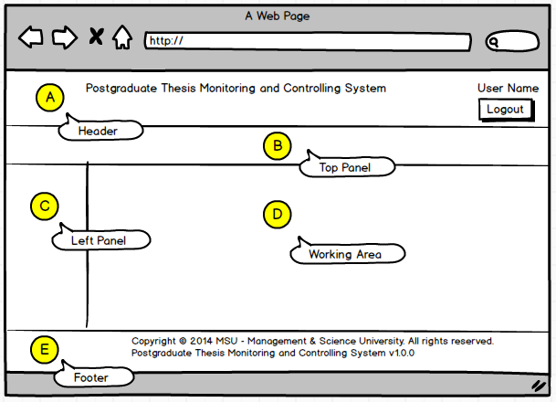

Figure 2: THEMES Screen Structure Design

# HIGHLEVEL FLOW

## Thesis Proposal Submission Process Flow

The figure below depicts the highlevel process flow for the thesis proposal submission which cover from the submission until its get approved by the Senate.

The dotted line as shown below is the focus covered in this manual.

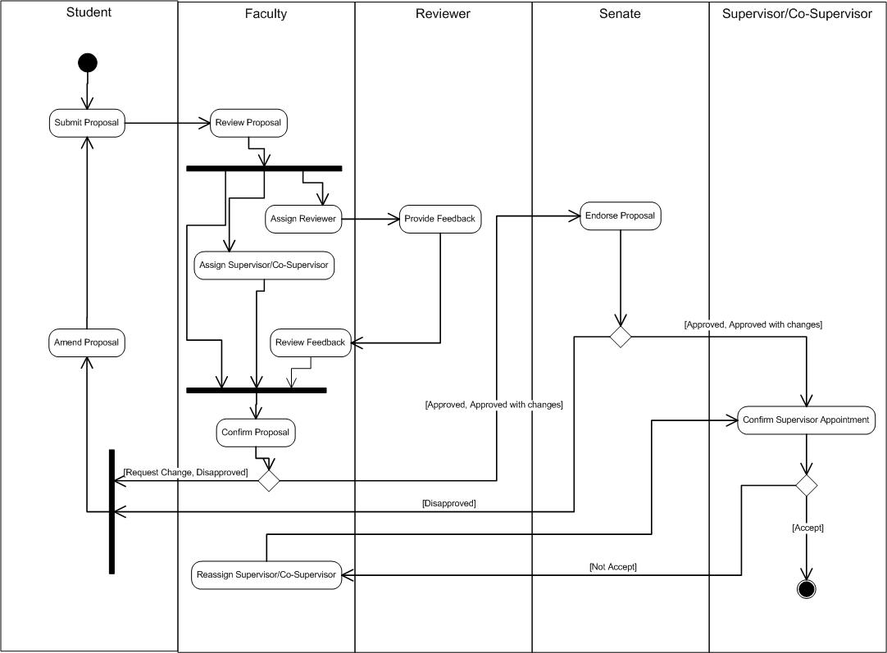

Figure 3: Thesis Proposal Submission Process Flow

## Defence Proposal Process Flow

The figure below depicts the highlevel process flow for the defence proposal submission which cover from the submission until its get approved by the Senate.

The dotted line as shown below is the area covered in this manual.

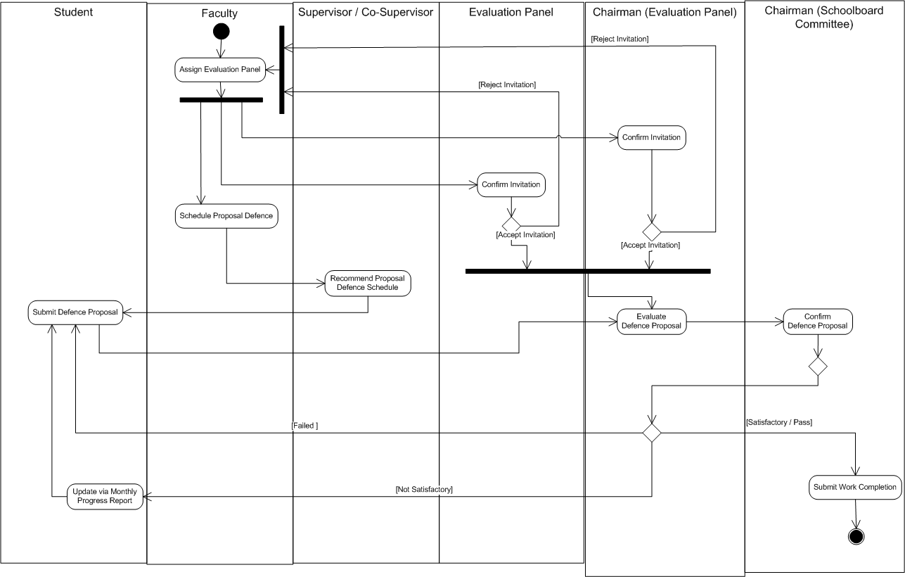

Figure 4: Defence Proposal Submission Process Flow

## Work Completion Process Flow



Figure 5: Work Completion Process Flow

## VIVA Evaluation Process Flow



Figure 6: VIVA Evaluation Process Flow

# MAIN

## Announcement

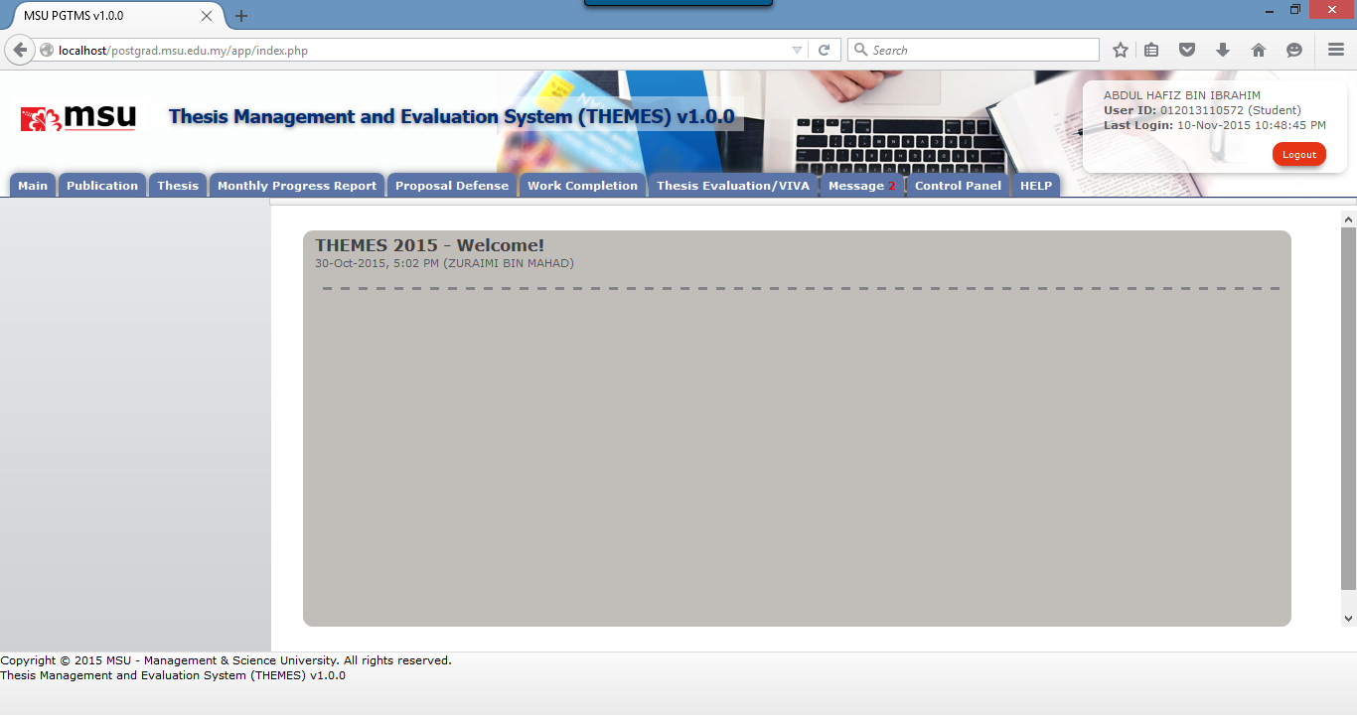

**1**

Figure 8: Announcement

**Prerequisite**

The user has to successfully login to the system first.

**Steps**

Observe the list of announcement as listed on the **Working Area** section

**Warning**

None

**Note**

Note

# LOGIN and LOGOUT

## Login

This is the first page sight by the student to enter the PGTMC system.

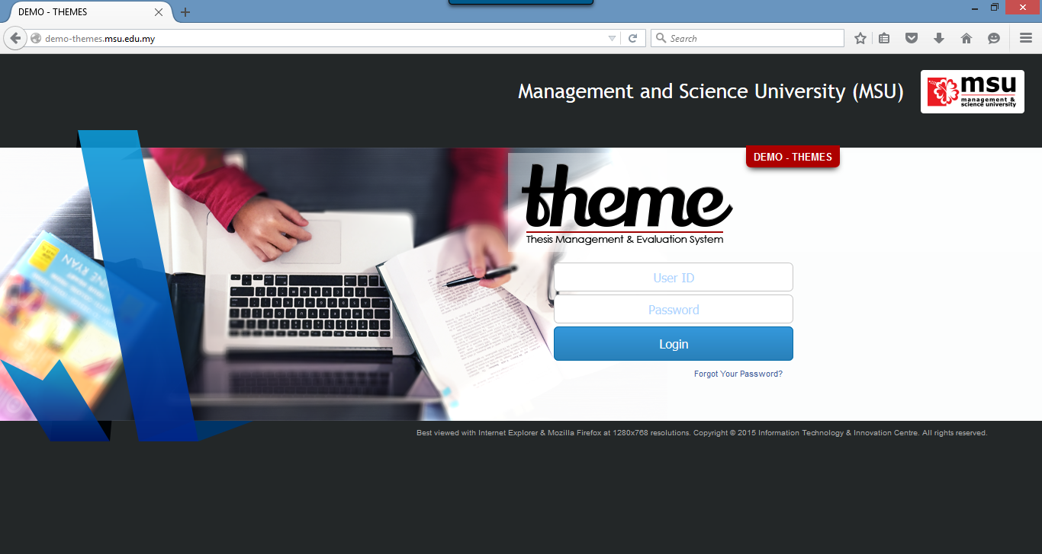

**2**

**1**

Figure 9: Login Page

**Prerequisite**

The user must have the User ID and Password registered with the THEMES system

**Steps**

1. Open the Internet Browser i.e. Mozilla Firefox or Microsoft Internet Explorer

Enter this URL <http://themes.msu.edu.my/> to access the system

1. Login page will be displayed in which the user needs to provide the **User ID** and **Password**.

**Warning**

1. If the provided **User ID** and **Password** are incorrect, the system will prompt an error message and the user needs to provide the right **User ID** and **Password** again.
2. Just in case the user forgot the password, it can be reset via the Forgot Your Password.

**Note**

None

## Logout

Once the necessary or required activities has been done or completed, the student can quit from the system by clicking on the **Logout** button.

If the system is keep idle for about 1 minute, the system will logged out the user automatically.

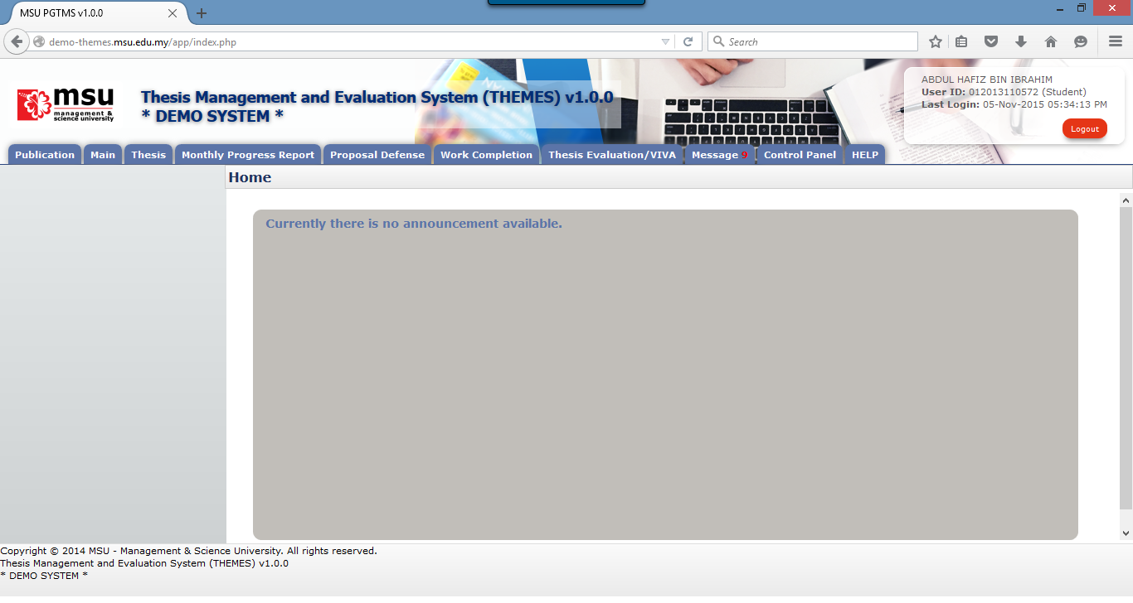

**1**

Figure 10: Logout Page

**Prerequisite**

The user has to successfully login to the system first.

**Step**

Find the **Logout** button located on the right top corner of the system **Header** section. Click on it and you will be logout from the system successfully.

**Warning**

None

**Note**

It is advisable to the user to properly logout from the system instead of force quit by closing the windows.

# THESIS

Thesis Profile listed all the supervisee under supervisor. Plus, the Supervisor can also view all the detail regarding supervisee. Search supervisee by Thesis ID/Title.

## Student Profile

View the student details which has the Student Profile, Supervisor/Co-supervisor lists, Subject Taken and Thesis History.

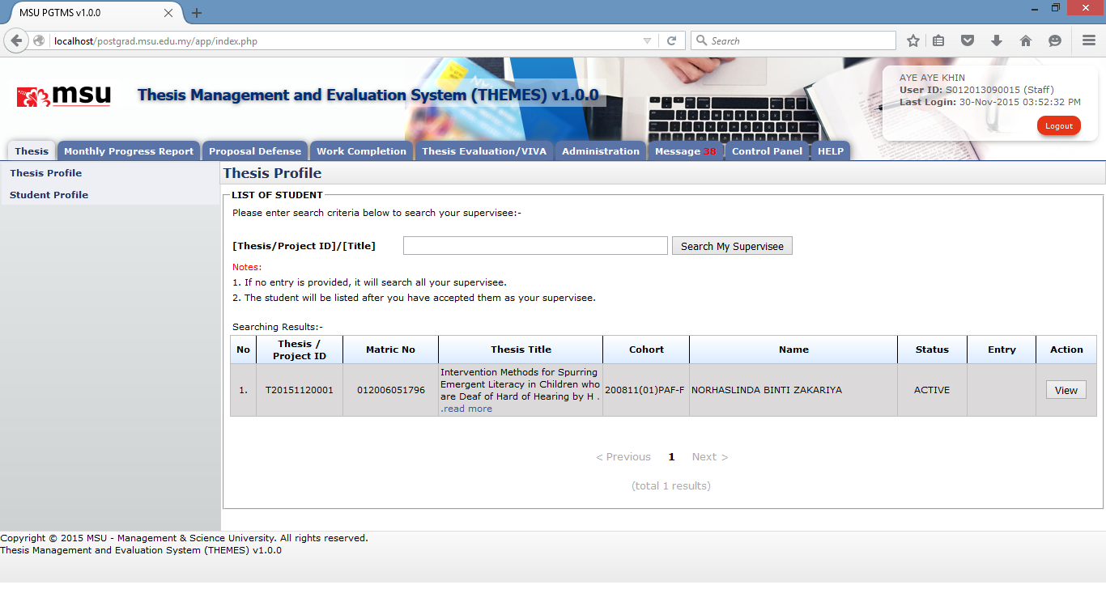

**4**

**3**

**2**

**1**

Figure 12: Thesis Tab

**Prerequisite**

All the postgraduate student record has been registered into the system

**Steps**

1. Click on the **Thesis** tab on the system **Top** panel section.
2. The **Student Profile** menu will be displayed on the system **Left** panel and click on it.
3. The searching page will be displayed which the user can search for a particular thesis in order to view its detail. Enter the **Thesis ID** or **Title**. into the field and click on **Search My Supervisee** button to search the thesis
4. The record will be displayed under the search result. Locate the student from the list and click **View** button to view the profile details

**Next Action**

View the Student Profile, Supervisor/Co-supervisor lists, Subject Taken and Thesis History

**Warning**

None

**Note**

None

### Student Profile

Student Profile tab contains the basic student and thesis information including its thesis progress status

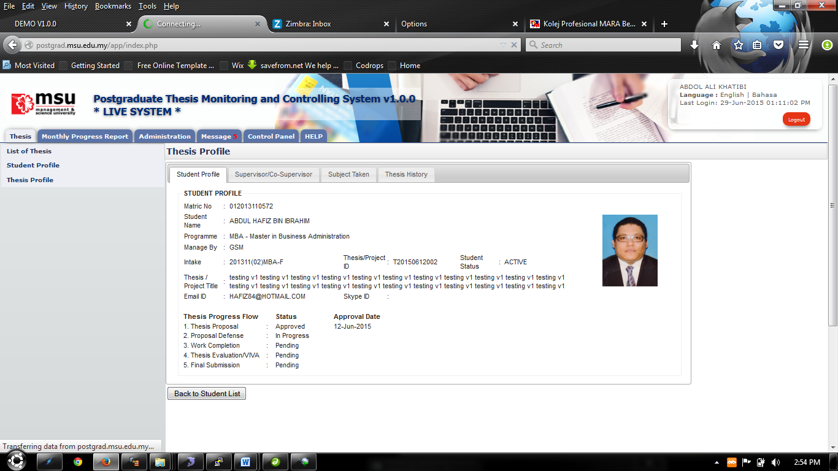

**2**

**1**

Figure 13: Student Profile Tab

**Prerequisite**

The student has been selected

**Steps**

1. View information.
2. Click **Back to Student List** button to return back to **Student List** search page

**Next Action**

None

**Warning**

None

**Note**

None

### Supervisor/Co-Supervisor List

Supervisor or Co-Supervisor is the academic staff who has been assigned by Faculty to supervise the student in delivering the thesis and approved by the Senate.

There are conditions for the student to see the list of his/her supervisors. The conditions are:-

1. Supervisor/Co-Supervisor has been assigned by Faculty and approved by the Senate
2. Supervisor/Co-Supervisor has accepted the appointment to supervise the student.

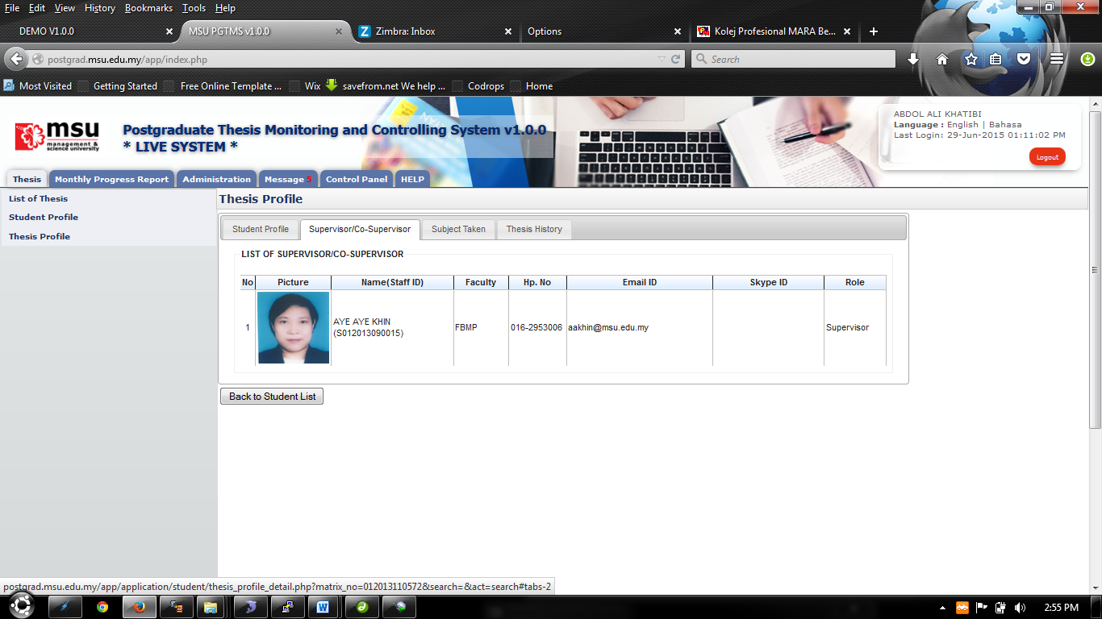

**2**

**1**

Figure 14: List of Supervisor / Co-Supervisor

**Prerequisite**

The student has been selected

**Steps**

1. View information.
2. Click **Back to Student List** button to return back to **Student List** search page

**Next Action**

None

**Warning**

None

**Note**

None

### Subject Taken

Subject Taken tab will list the entire subject registered by the students for all semester during his study.

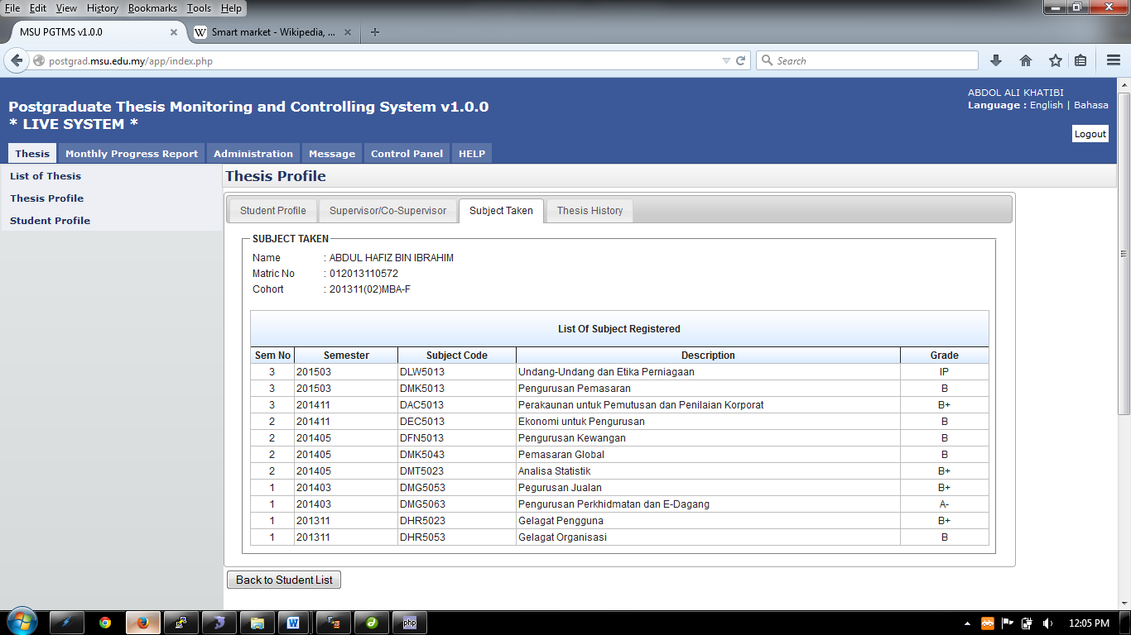

**1**

**2**

Figure 15: Subject Taken

**Prerequisite**

The student has been selected

**Steps**

1. View information.
2. Click **Back to Student List** button to return back to **Student List** search page

**Next Action**

None

**Warning**

None

**Note**

None

### Thesis History

Thesis History tab contains the proposal progress history starting from its submission by the student until its approval by the Senate. It captures the date of

****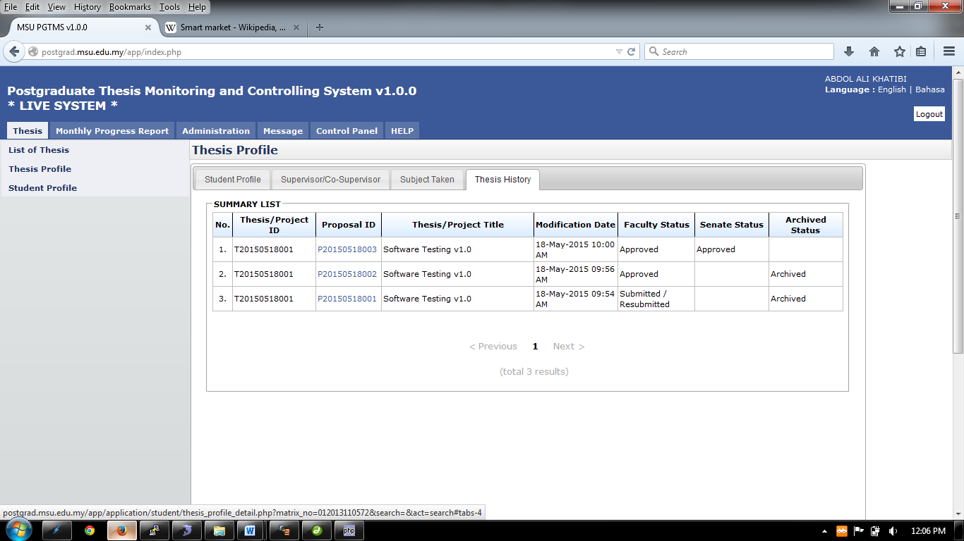

**1**

**2**

Figure 16: Thesis Tab – Thesis History

**Prerequisite**

The student has been selected

**Steps**

1. View information.
2. Click **Back to Student List** button to return back to **Student List** search page

**Next Action**

None

**Warning**

None

**Note**

None

## Thesis Profile

Thesis profile can be retrieved via student’s **Name** or **Matrix Number**.

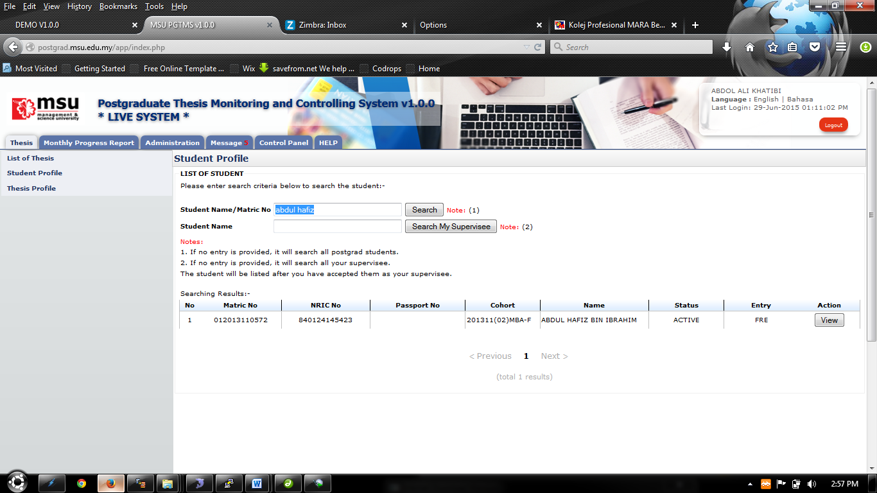

**1**

**4**

**3**

**2**

Figure 17: Thesis Tab – List of Student

**Prerequisite**

All the postgraduate student record has been registered into the system

**Steps**

1. Click on the **Thesis** tab on the system **Top** panel section.
2. The **Student Profile** menu will be displayed on the system **Left** panel and click on it.
3. The searching page will be displayed which the user can search for a particular student in order to view its detail. Enter the **Student’s Name** or **Matrix No**. into the field and click on **Search** button to search the student.
4. The record will be displayed under the search result. Locate the student from the list and click **View** button to view the profile details

**Next Action**

View the Student Profile, Supervisor/Co-supervisor lists, Subject Taken and Thesis History

**Warning**

None

**Note**

None

### Student Profile Details

View the student details which has the Student Profile, Supervisor/Co-supervisor lists, Subject Taken and Thesis History.

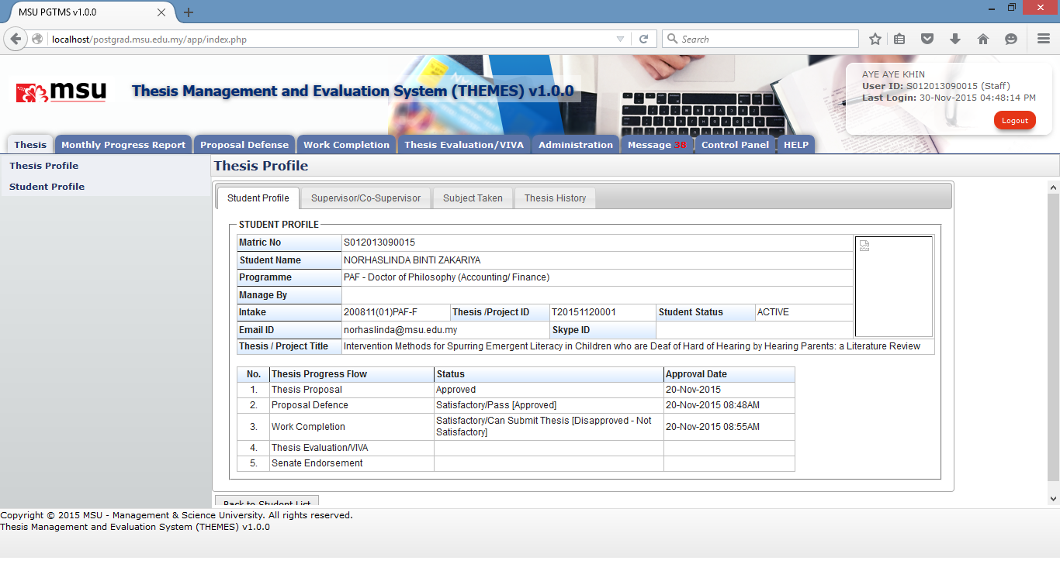

**2**

**1**

Figure 18: Thesis Tab – Student Profile

**Prerequisite**

The student has been selected

**Steps**

1. View information.
2. Click **Back to Student List** button to return back to **Student List** search page

**Next Action**

None

**Warning**

None

**Note**

None

### Supervisor/Co-Supervisor List

Supervisor or Co-Supervisor is the academic staff who has been assigned by Faculty to supervise the student in delivering the thesis and approved by the Senate.

There are conditions for the student to see the list of his/her supervisors. The conditions are:-

1. Supervisor/Co-Supervisor has been assigned by Faculty and approved by the Senate
2. Supervisor/Co-Supervisor has accepted the appointment to supervise the student.



**1**

**2**

Figure 19: Thesis Tab - List of Supervisor / Co-Supervisor

**Prerequisite**

The student has been selected

**Steps**

1. View information.
2. Click **Back to Student List** button to return back to **Student List** search page

**Next Action**

None

**Warning**

None

**Note**

None

### Subject Taken

Subject Taken tab will list the entire subject registered by the students for all semester during his study.



**2**

**1**

Figure 20: Thesis Tab - Subject Taken

**Prerequisite**

The student has been selected

**Steps**

1. View information.
2. Click **Back to Student List** button to return back to **Student List** search page

**Next Action**

None

**Warning**

None

**Note**

None

### Thesis History

Thesis History tab contains the proposal progress history starting from its submission by the student till its approval by the Senate. It captures the date of

****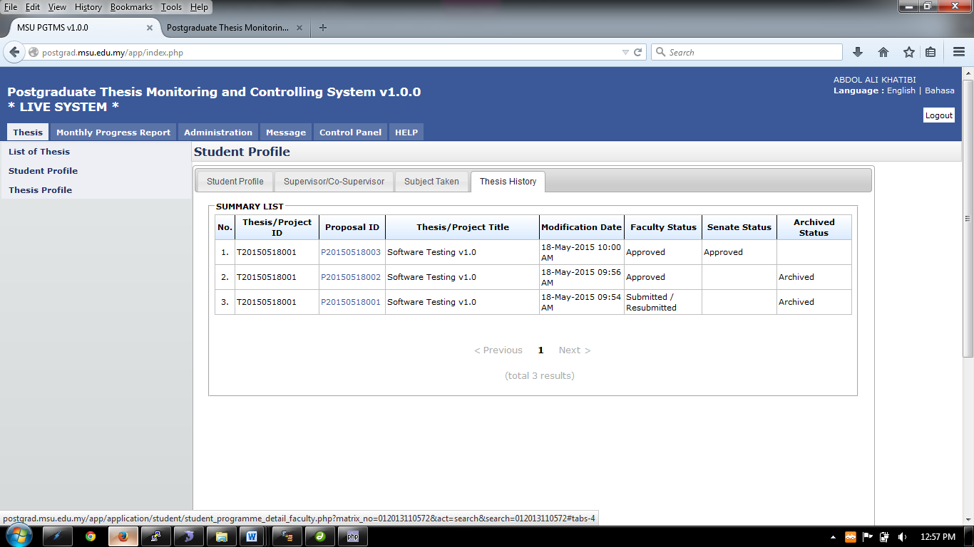

**1**

**2**

Figure 21: Thesis Tab – Thesis History

**Prerequisite**

The student has been selected

**Steps**

1. View information.
2. Click **Back to Student List** button to return back to **Student List** search page

**Next Action**

None

**Warning**

None

**Note**

None

# Monthly Progress Report

## Review Progress Report

### Update Progress Report

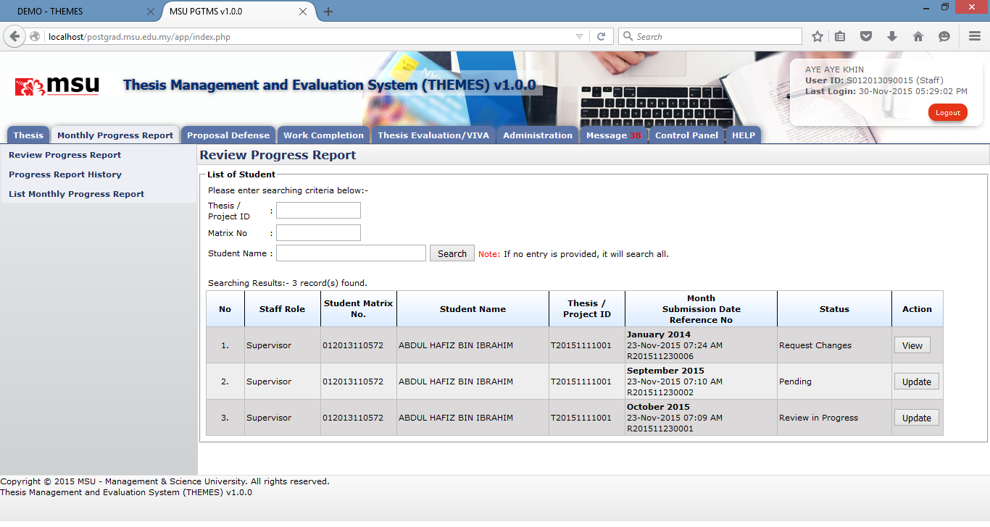

**5**

**4**

**3**

**2**

**1**

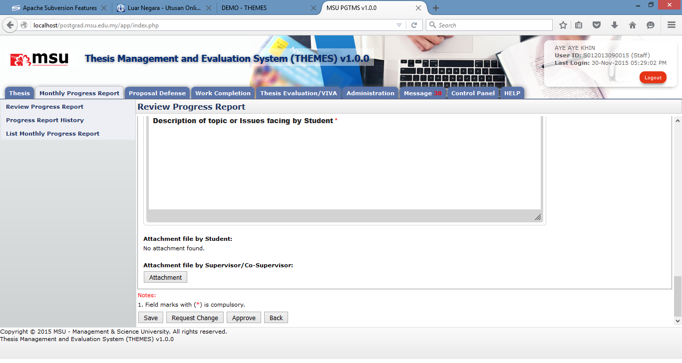

**6**

Figure 21: Update Defence Proposal

**Prerequisite**

The student has submitted the monthly progress report.

**Steps**

1. Click on **Monthly Progress Report** on the **Top Panel** section.
2. The list of menu will be displayed on the **Left Panel** section. Click on the **Review Progress Report** menu link.
3. The **Review Progress Page** will be displayed on the **Working Area** section. Enter the searching criteria if to get specific result or just click the **Search** button to get the general result.
4. The result will be displayed on the result searching list.
5. Find the monthly progress report for the student which the status is **Pending** or **Review in Progress**, click on **Update** button to give the feedback.
6. The Report Details page will be displayed. Provide the feedback and attachment (if any).
   1. Click on the **Save** button if you want to review and update it again later.
   2. Click on **Request** **Change** if you want the student re-update the report and re-submit.
   3. Click on the **Approve** button if the report is acceptable.

**Next Action**

If the feedback is Request Change, then the Student needs to do the required changes and resubmit back to the Faculty. The Faculty user needs to keep checking this monthly report for approval.

**Warning**

None

**Note**

None

### View Progress Report

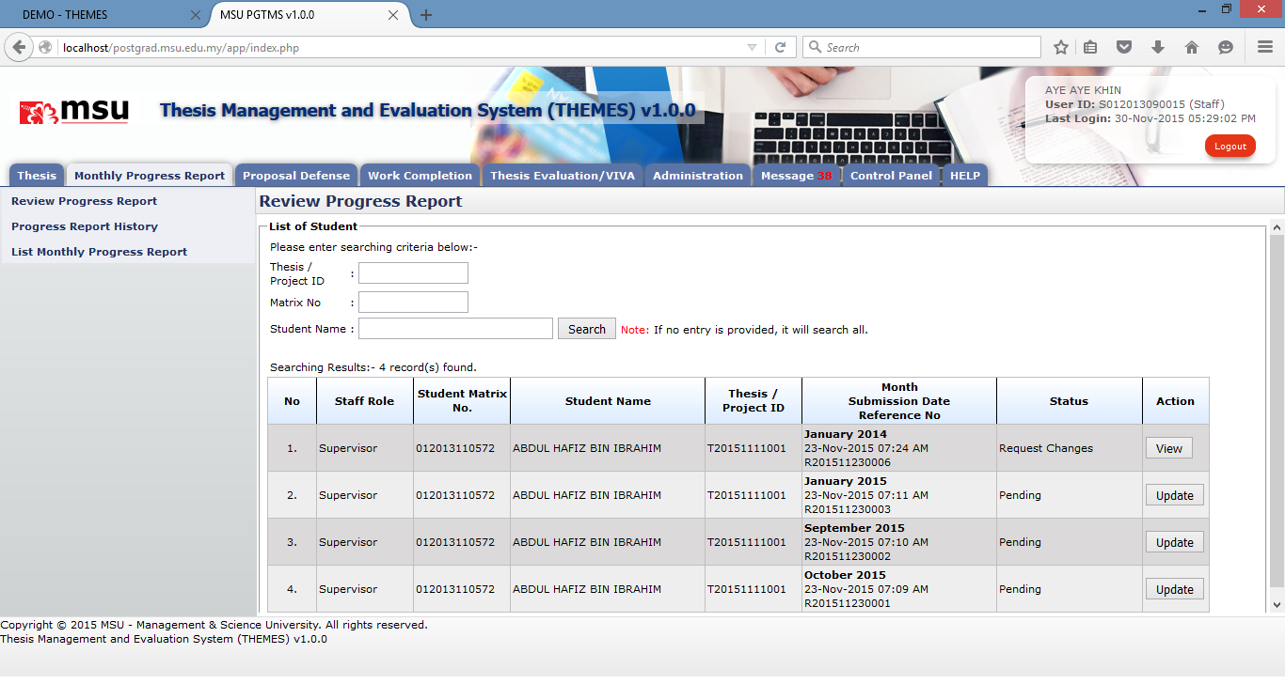

**1**

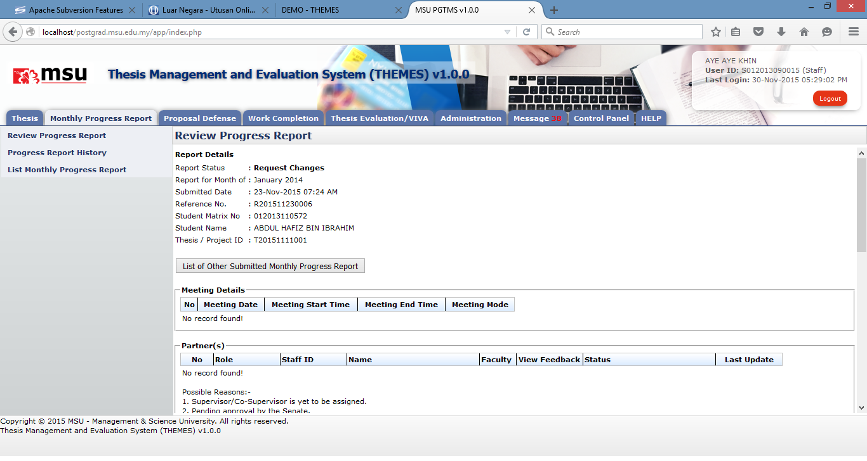

**2**

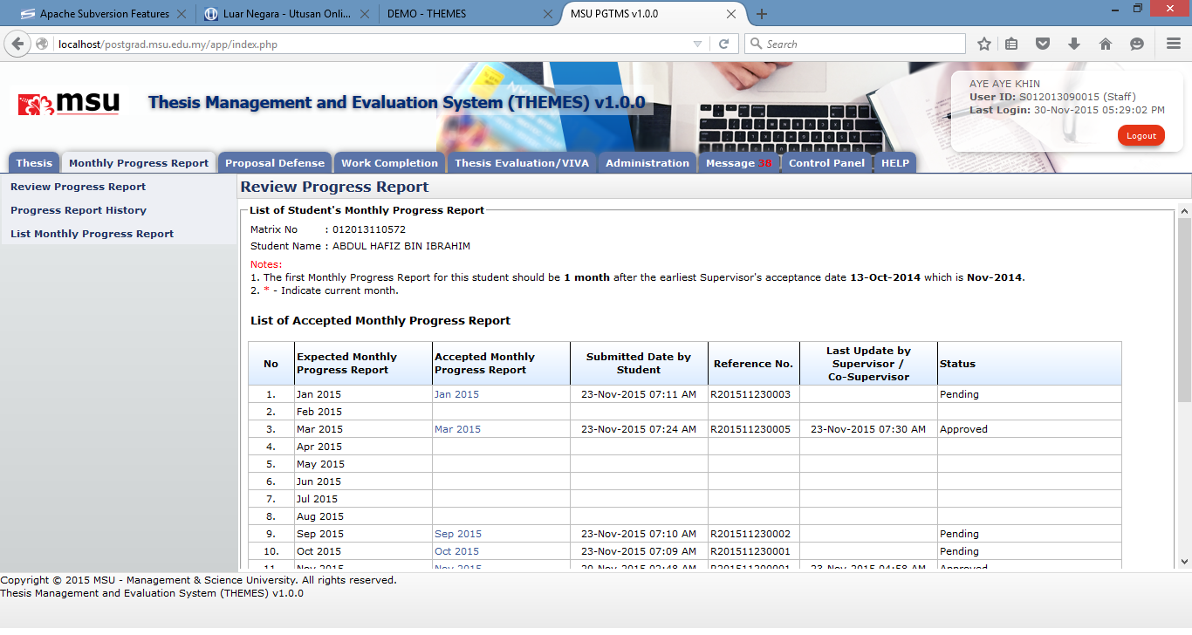

**3**

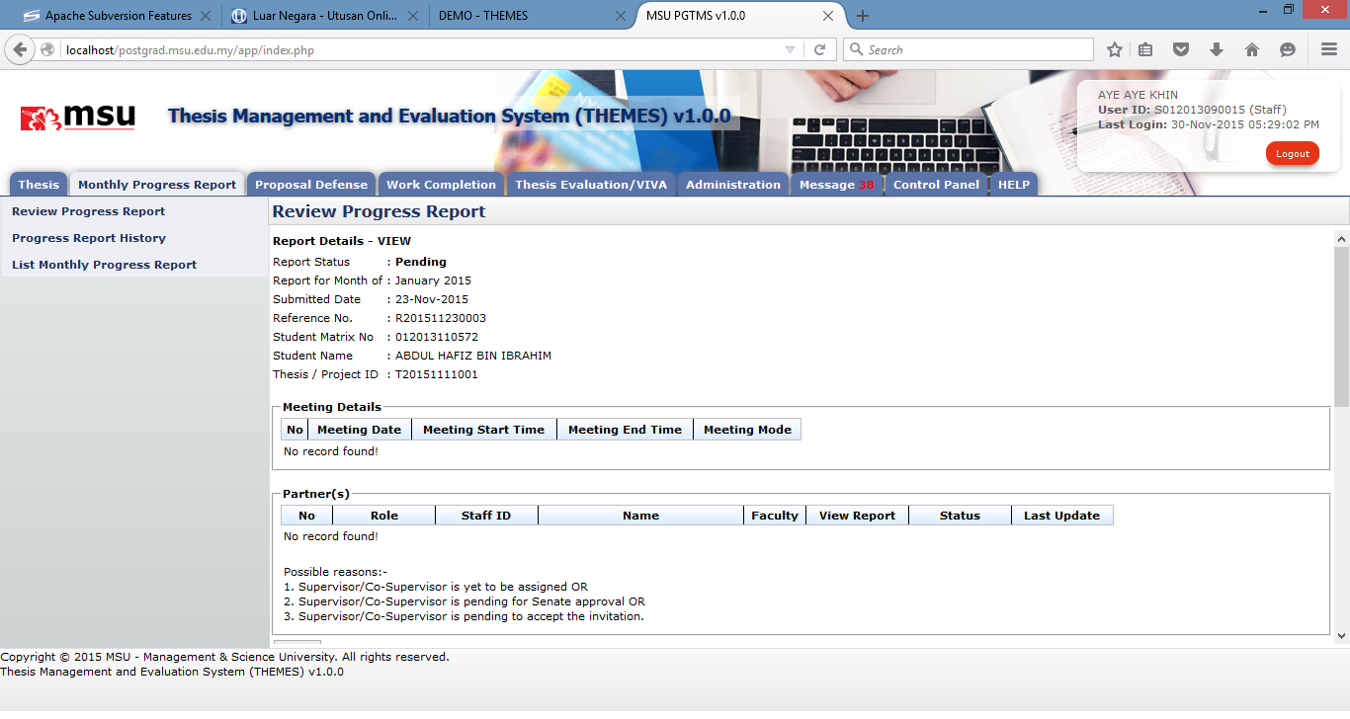

**4**

Figure 21: View Defence Proposal

**Prerequisite**

The student has submitted the monthly progress report.

**Steps**

1. Find the monthly progress report for the student which the status is **Request Change**, click on **View** button to view the detail.
2. The Report Details page will be displayed. Click on the **List of Other Submitted Monthly Progress Report** button if you want to view the detail of other monthly report.
3. The list of monthly report will be displayed. You can click on the available link to view the detail.
4. The selected report detail will be displayed.

**Next Action**

None

**Warning**

None

**Note**

None

## Progress Report History

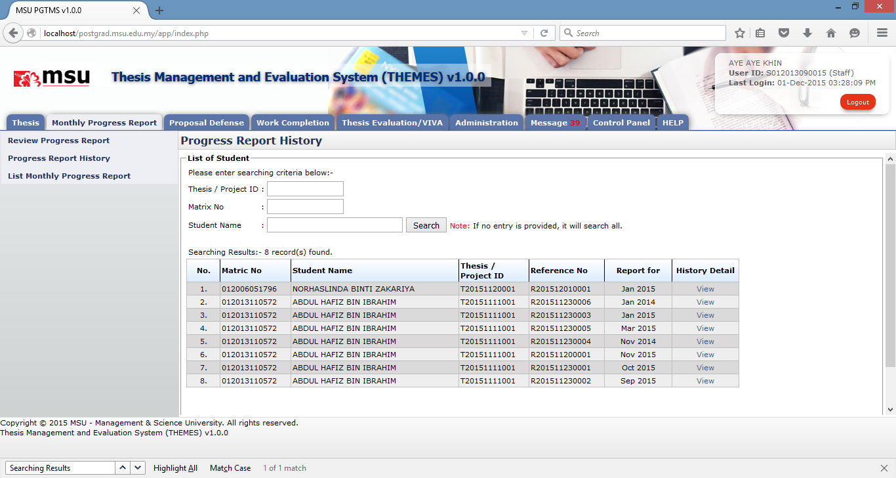

**5**

**4**

**3**

**1**

**2**

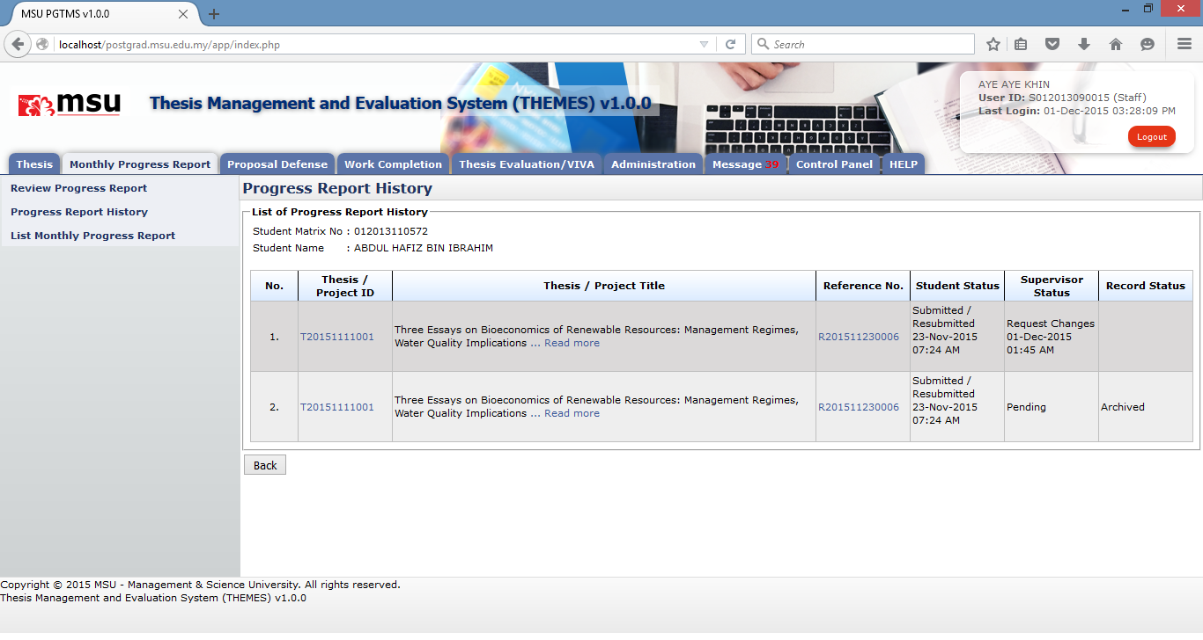

**6**

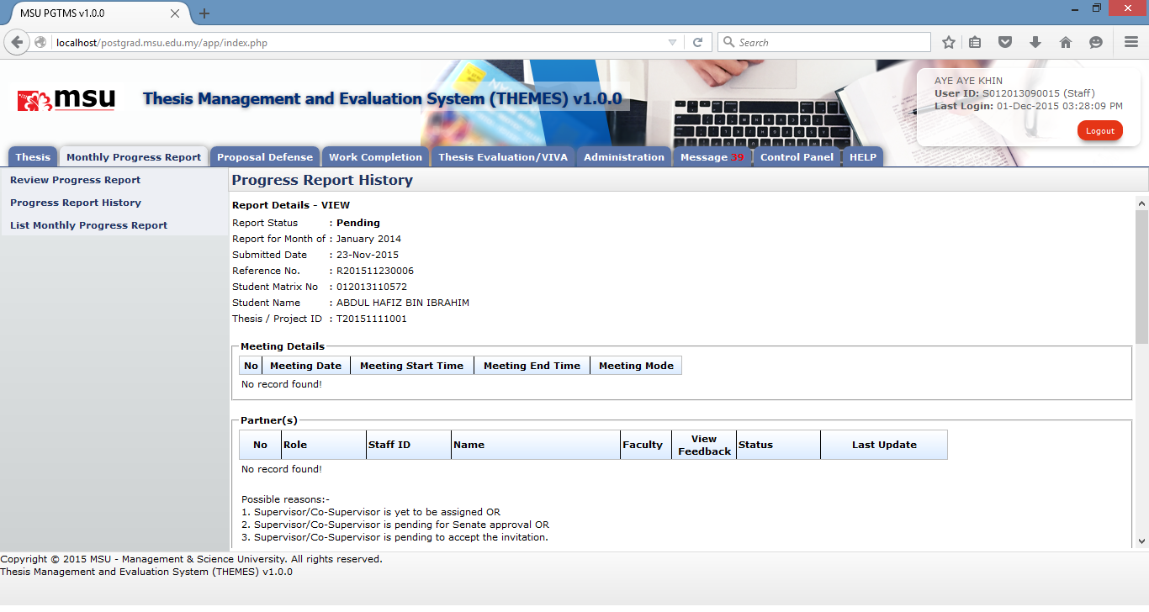

**7**

Figure 21: Progress Report History

**Prerequisite**

The student has submitted the monthly progress report.

**Steps**

1. Click on **Monthly Progress Report** on the **Top Panel** section.
2. The list of menu will be displayed on the **Left Panel** section. Click on the **Progress** **Report History** menu link.
3. The **Progress** **Report History** page will be displayed on the **Working Area** section. Enter the searching criteria if to get specific result or just click the **Search** button to get the general result.
4. The result will be displayed on the result searching list.
5. Find the monthly progress report for the student which the status and click on **View** button to view the detail.
6. The history page will be displayed. Click on the **Reference no** link if you want to view the detail of other monthly report.
7. The next following page will be displayed and shows the selected history detail.

**Next Action**

None

**Warning**

None

**Note**

None

## List Monthly Progress Report

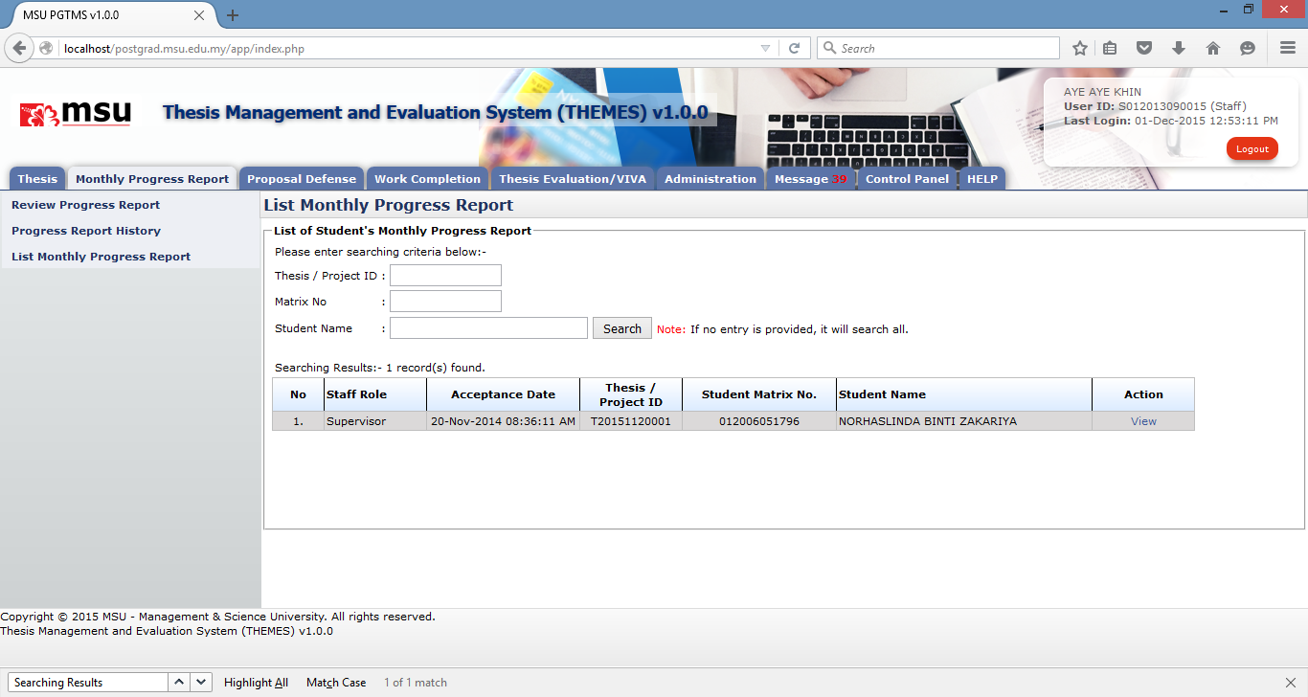

**5**

**4**

**3**

**2**

**1**

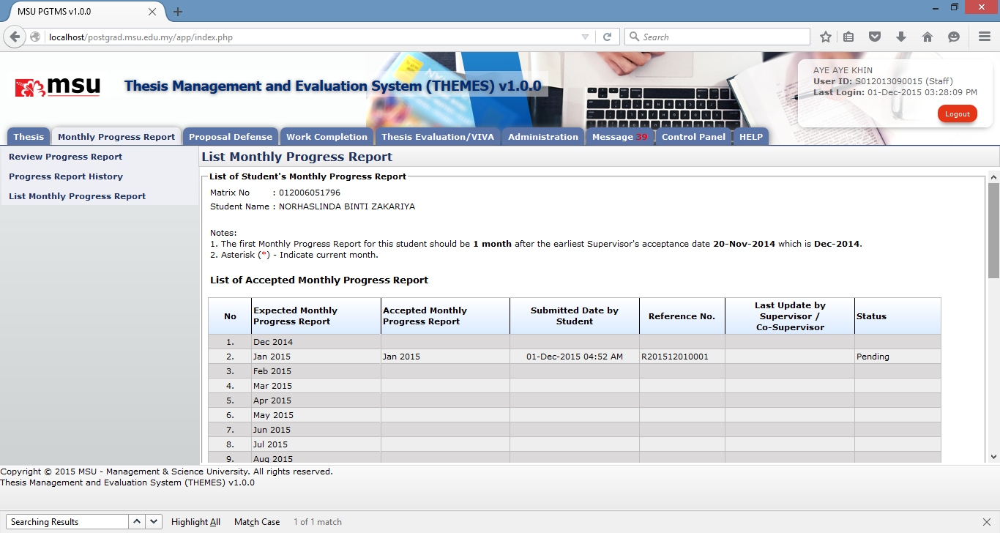

**6**

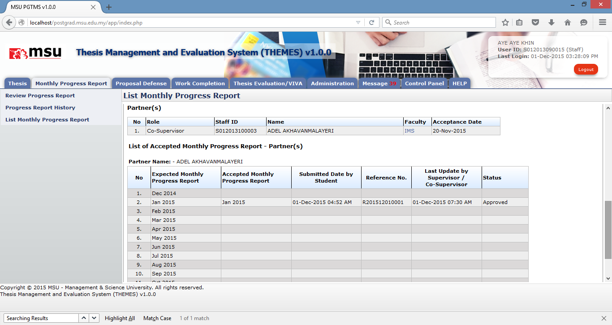

**7**

Figure 21: List Monthly Progress Report

**Prerequisite**

The student has submitted the monthly progress report.

**Steps**

1. Click on **Monthly Progress Report** on the **Top Panel** section.
2. The list of menu will be displayed on the **Left Panel** section. Click on the **List Monthly Progress Report** menu link.
3. The **List Monthly Progress Report** will be displayed on the **Working Area** section. Enter the searching criteria if to get specific result or just click the **Search** button to get the general result.
4. The result will be displayed on the result searching list.
5. Find the monthly progress report for the student and click on **View** button to view the detail.
6. The Report Details page will be displayed. The section in dotted line shows the current status of monthly progress report from the Supervisor’s view
7. Whilst the other section of dotted line shows the current status of monthly progress report from the partner’s view.

**Next Action**

None

**Warning**

None

**Note**

None

# Proposal Defence

## Review Defence Proposal

### Update Defence Proposal

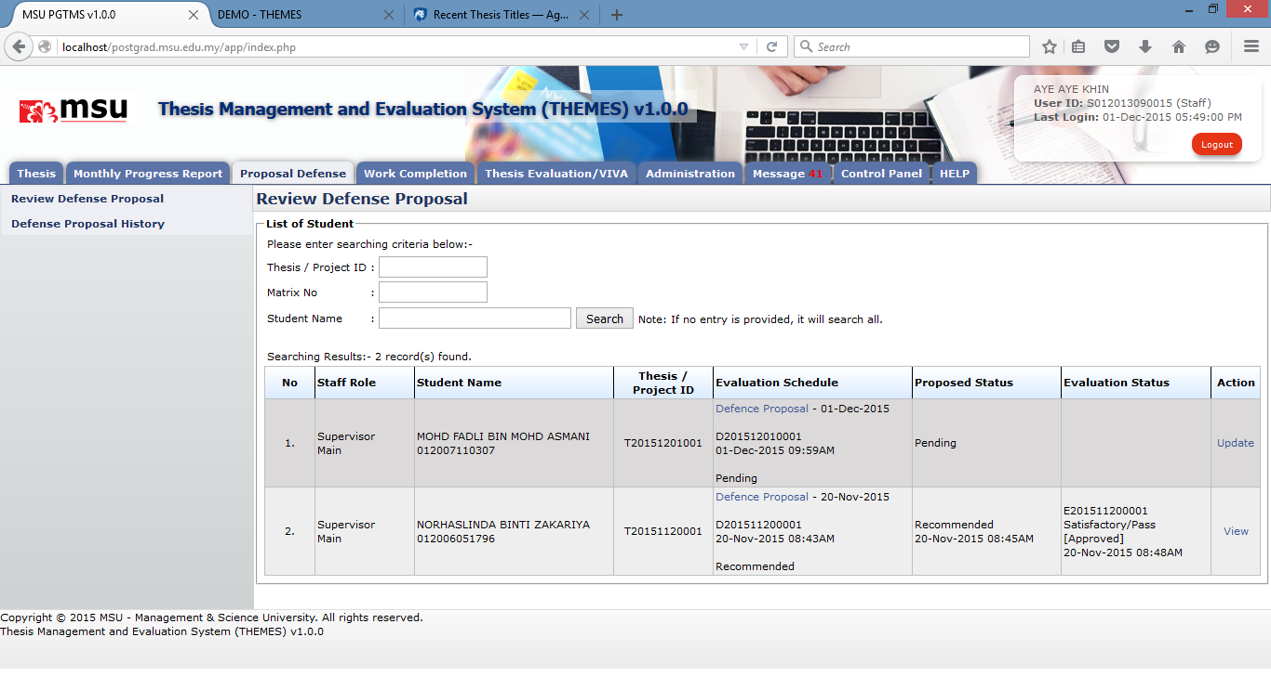

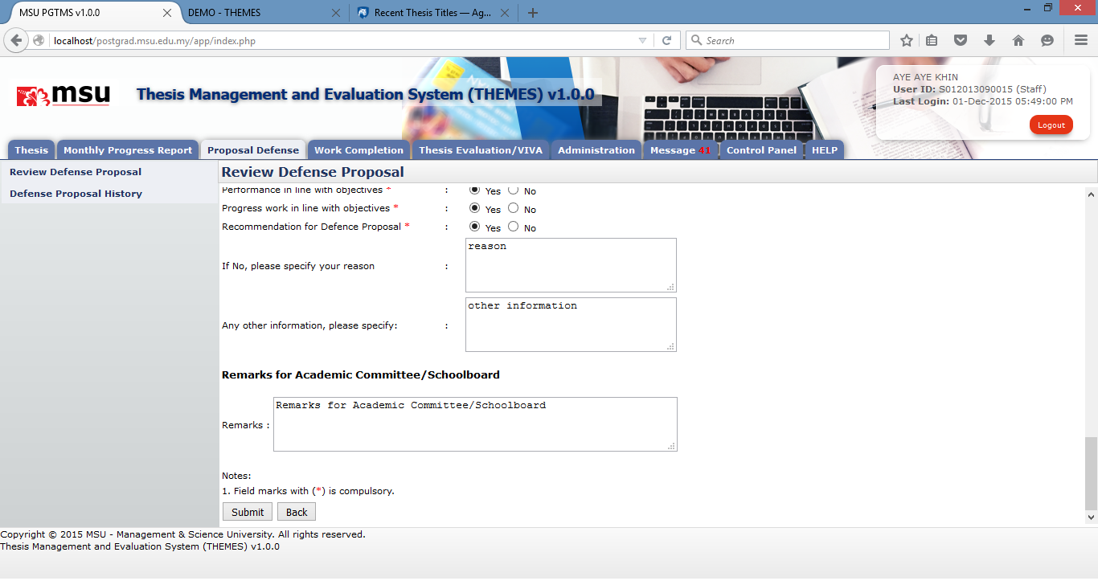

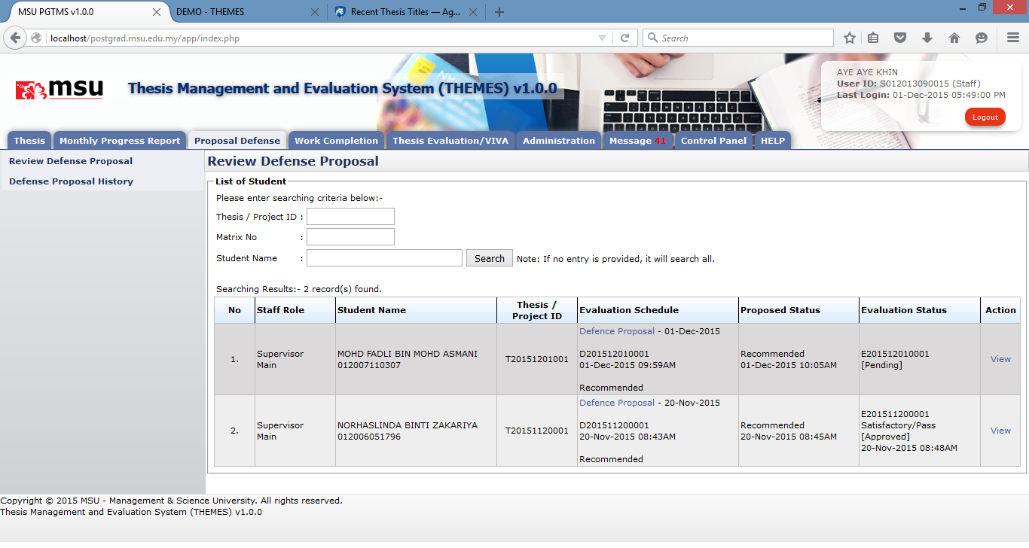

### View Defence Proposal



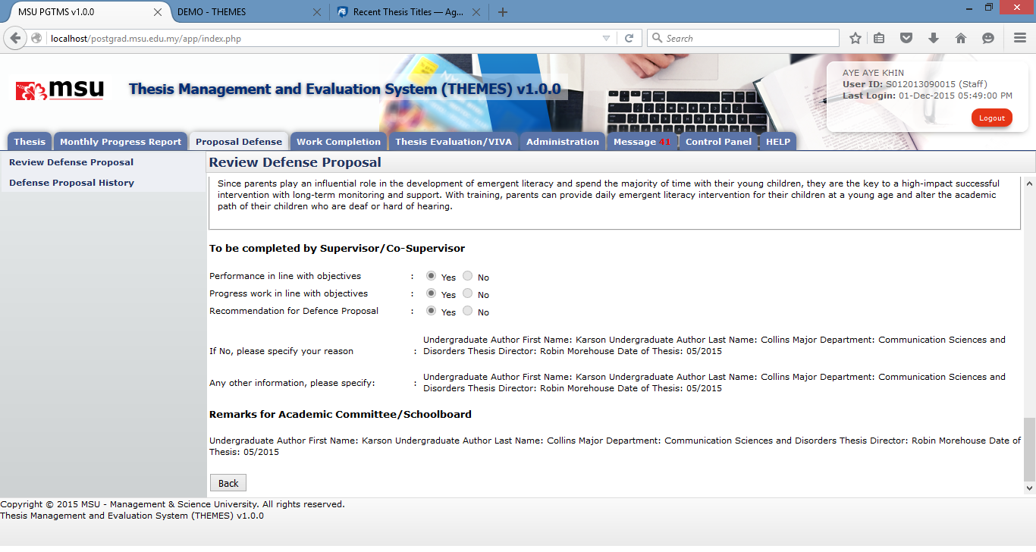

## Defence Proposal History

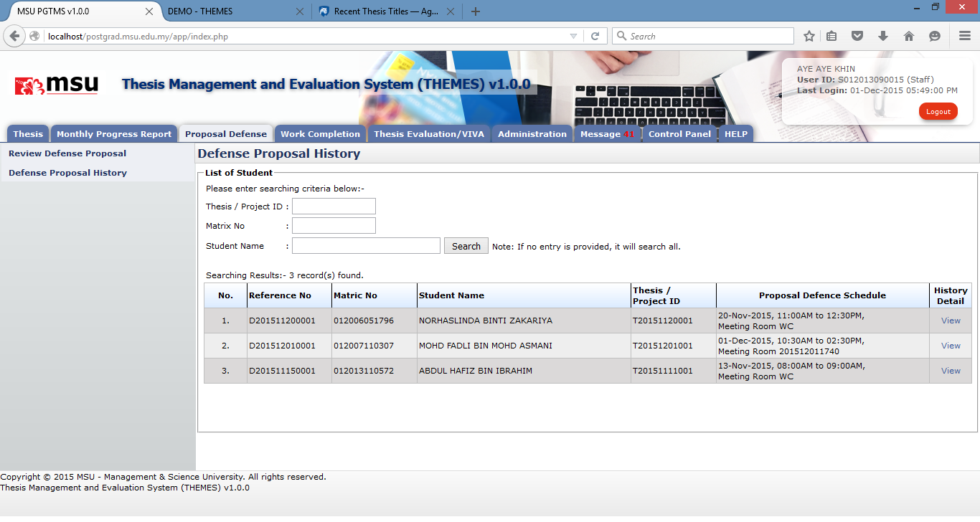

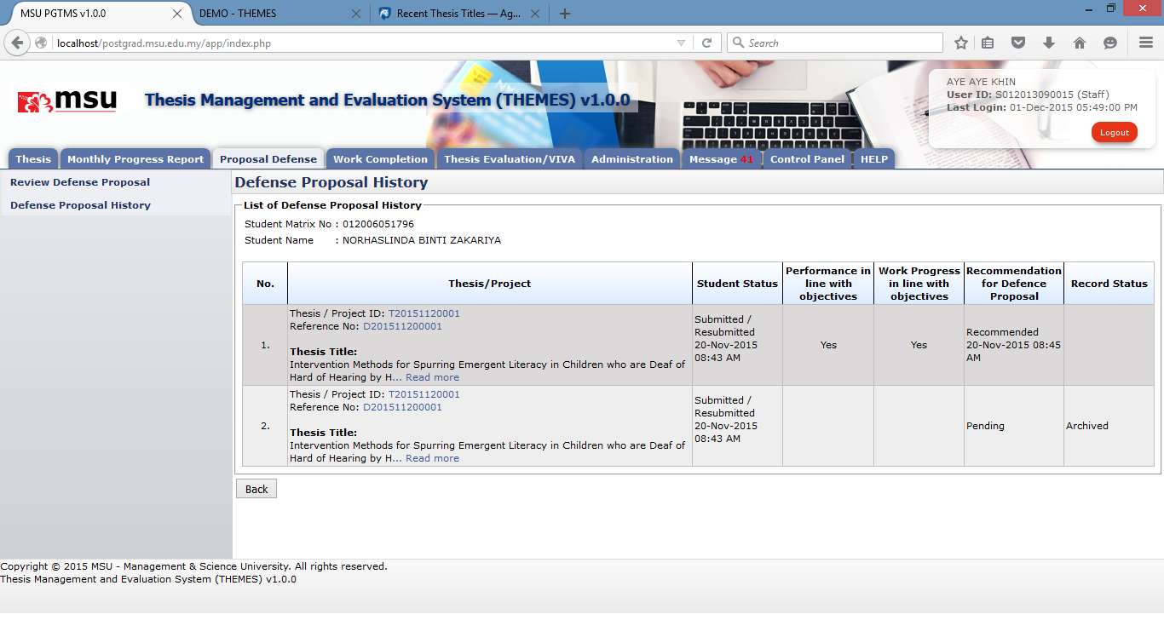

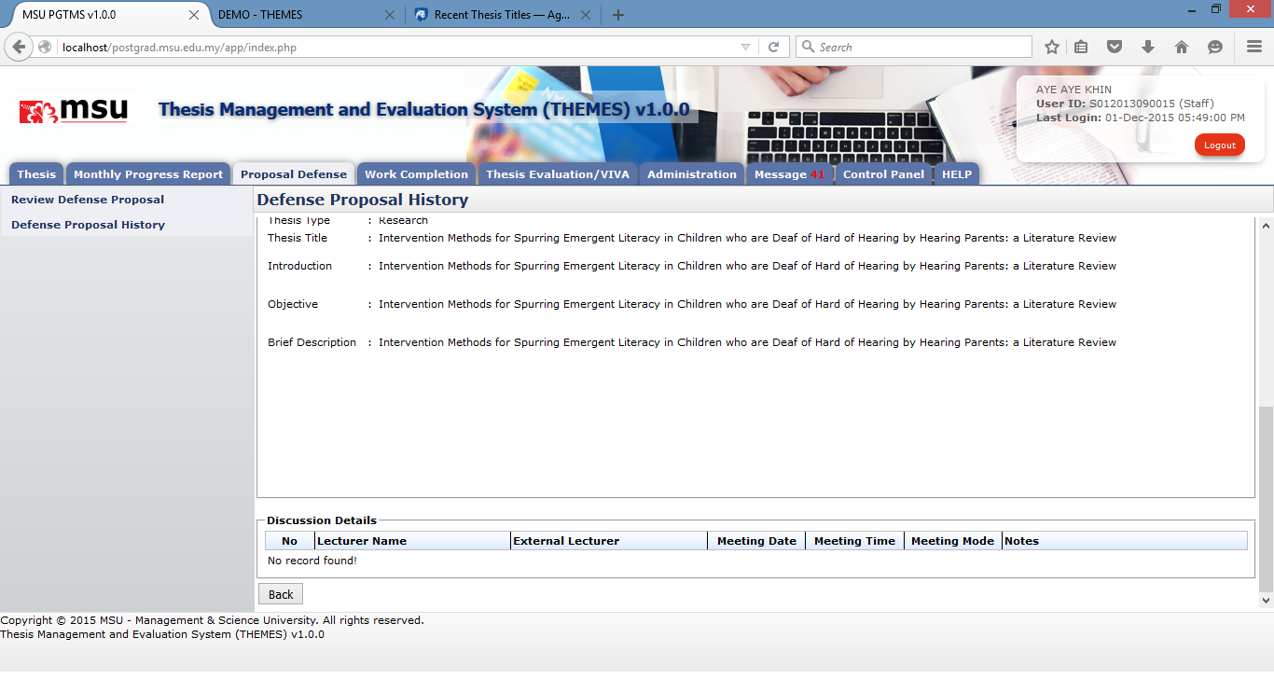

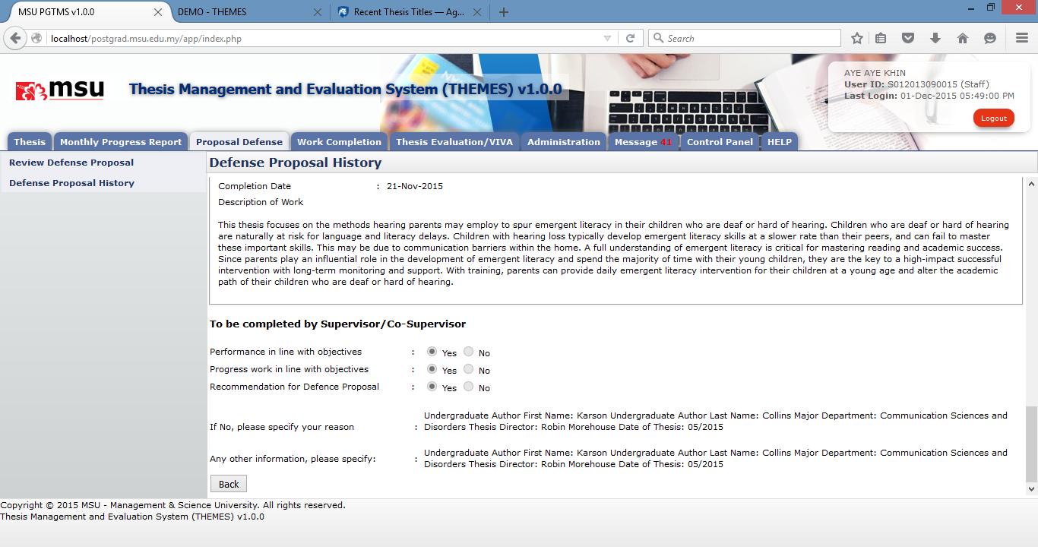

# Work Completion - NOK

## Review Work Completion

## Work Completion History

## Review Amendmen

# Thesis Evaluation / VIVA

## Review Thesis for VIVA

### Review Thesis

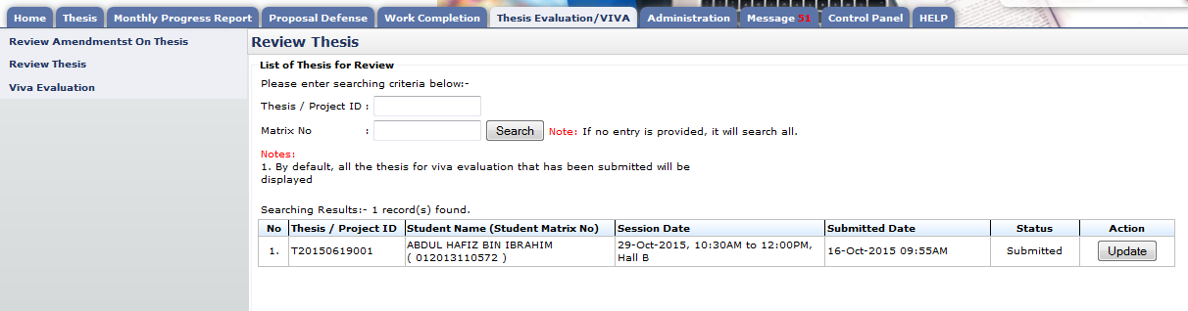

Figure 45: Review Thesis

**Pre-condition**

1. After Student submitted thesis for VIVA

**Post-condition**

1. Can request changes and review student thesis
2. Can submit thesis for VIVA evaluation

**Steps:-**

1. Click on the **Thesis Evaluation/VIVA** tab on the **Top** panel
2. Click on the **Review Thesis** menu on the **Left** panel
3. System will display the thesis for viva that need to be submitted by user.

#### Review Thesis

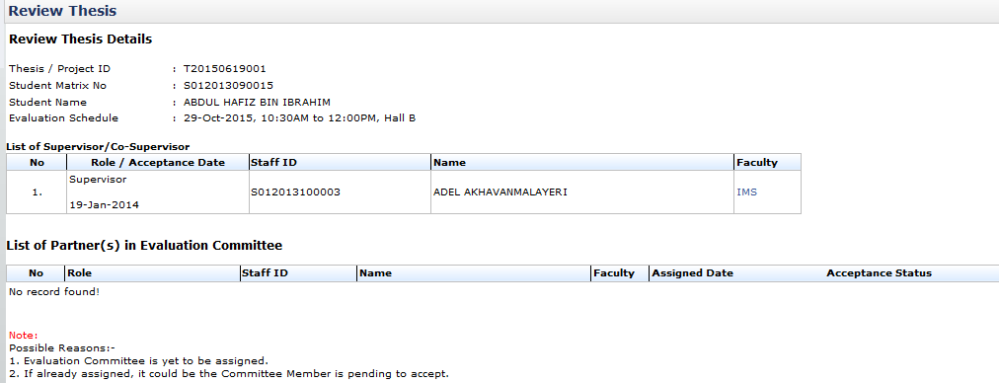

Figure 46: Review Thesis

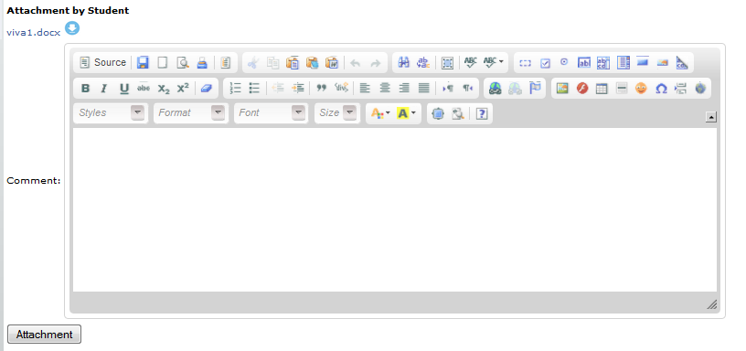

To upload attachment

Figure 47: Review Thesis

**Pre-condition**

1. Student must submitted thesis for VIVA

**Post-condition**

1. Can request changes and review student thesis
2. Can submit thesis for VIVA evaluation

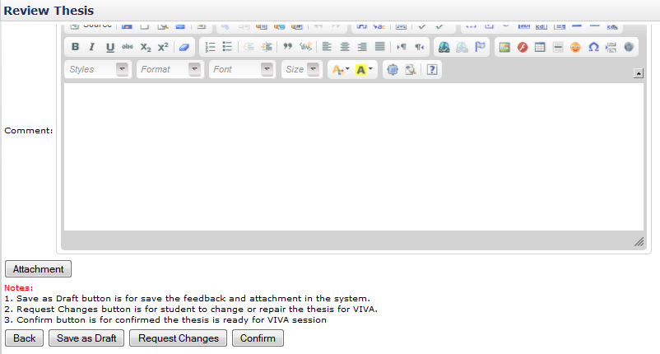

Figure 48: Review Thesis

**Steps:-**

1. To insert comment or remarks, insert detail into text field provided shown on figure 47
2. To save comment or remark, click **Save as Draft** button (refer figure 47)
3. To make a request changes to a student, click **Request Changes** button (refer figure 47)
4. To verified or confirm the thesis and proceed to viva evaluation, click **Confirm** button.
5. To upload thesis, click **Attachment** button (refer figure 47 & refer figure 48)

#### Upload attachment

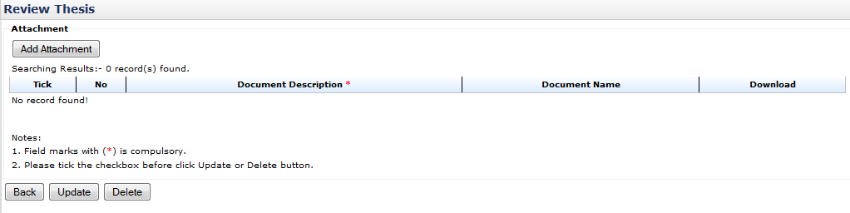

Add Attachment

Figure 49: Upload Attachment

**Post-condition**

1. Document Description can be update
2. Attachment can be deleted

**Steps:-**

1. To upload attachment/thesis click **Add Attachment** button (refer figure 48)
2. Then popup like figure 49 will appear and click **browse** button.
3. Choose necessary file for upload like figure 68 and click **Open** button.
4. After done choose file for upload. Insert file description and click **Insert Attachment** button to proceed.
5. Then click **Done** button (refer figure 52)
6. To change file and file description, click **Reset** button.
7. To stop from uploaded or close popup windows. Click **Exit** button or (**X**) windows button.

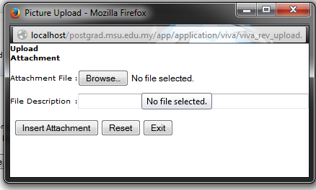

Figure 50: Upload Attachment

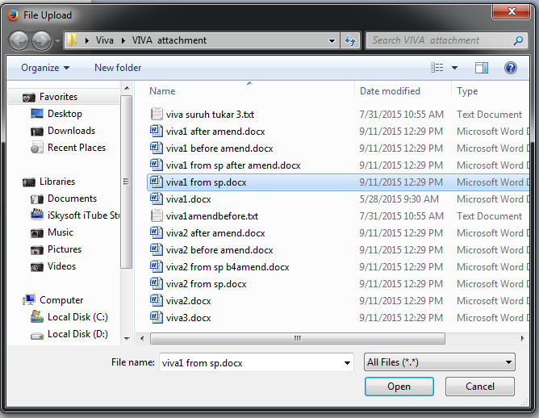

Figure 51: Upload Attachment

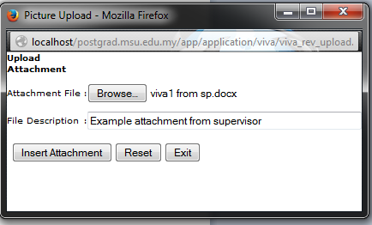

Figure 52: Upload Attachment

1. Continue from step 5, to update file/document description. Change the text inside text field provided. Then tick the checkbox placed on the far left side and click **Update** button. (refer figure 53)
2. To download file uploaded, click 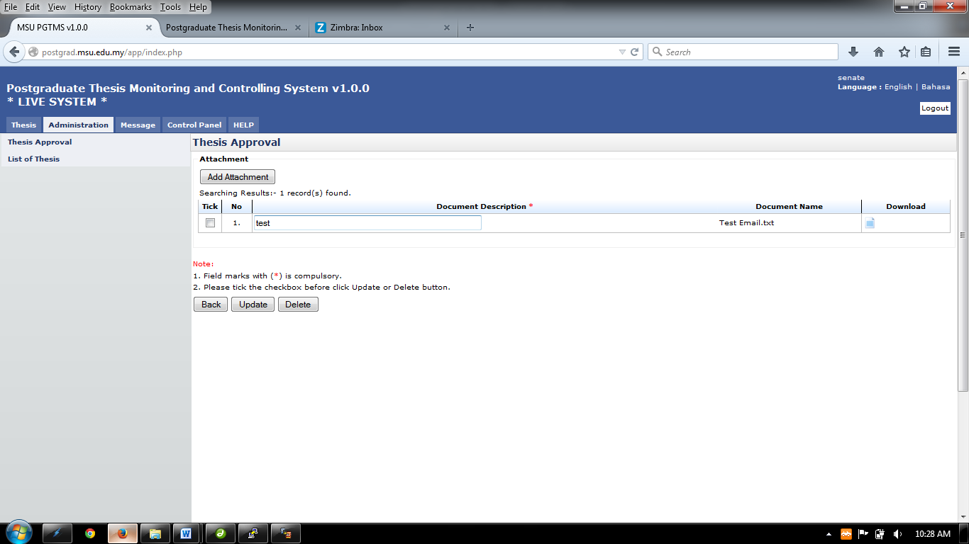button. (refer figure 53)
3. To delete uploaded file, tick the checkbox on the far left side of the table and click **Delete** button afterward. (refer figure 53)
4. Figure 72 is example of picture indicate number of uploaded file
5. To upload another file, repeat step 1
6. To go back to previous pages. Click **Back** button.

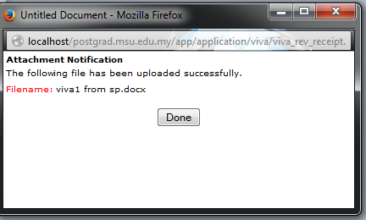

Figure 53: Upload Attachment

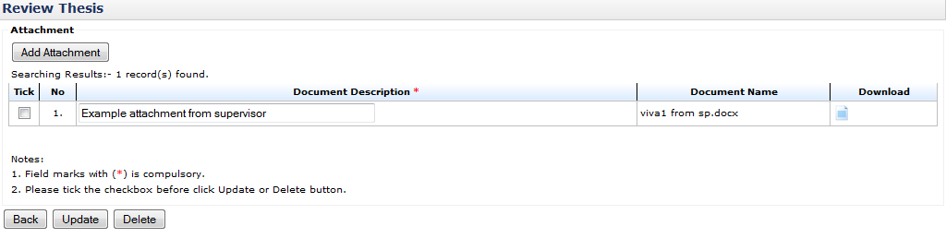

Figure 54: Upload Attachment

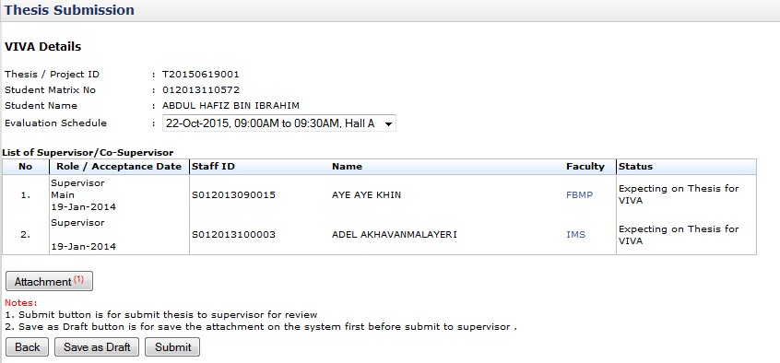

Figure 55: Indicate number of attachment uploaded

## VIVA Evaluation

### Viva Evaluation

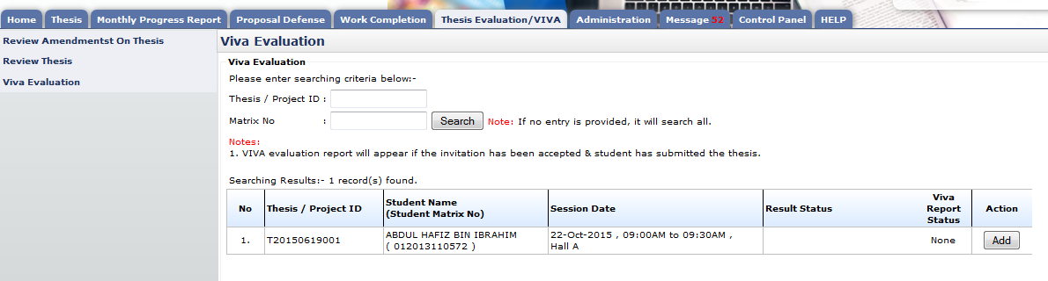

Figure 56: Review Thesis

**Pre-condition**

1. After Supervisor verified thesis for VIVA
2. After Accept Invitation

**Post-condition**

1. Can submit viva evaluation report

**Steps:-**

1. Click on the **Thesis Evaluation/VIVA** tab on the **Top** panel
2. Click on the **VIVA Evaluation** menu on the **Left** panel
3. System will display list of evaluation report

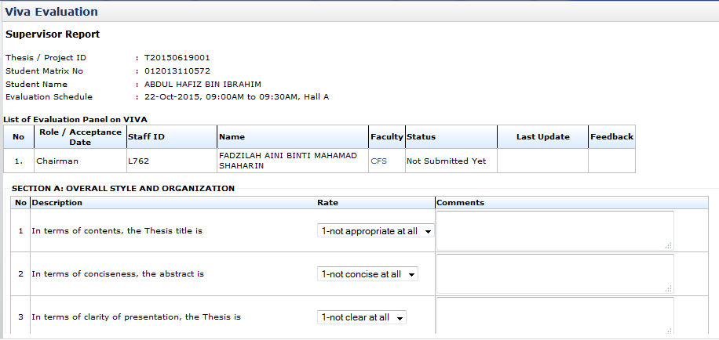

Figure 57: Review Thesis

List of field need to answer

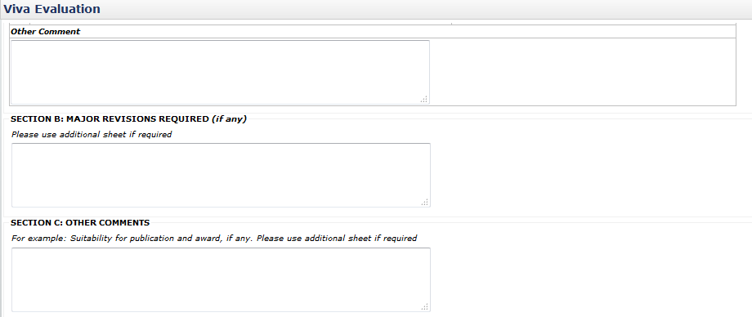

Text field provided for evaluation report

Figure 58: Review Thesis

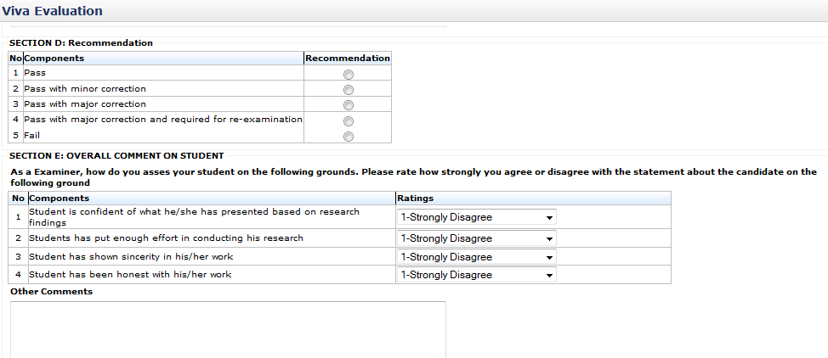

Figure 59: Review Thesis

Recommendation result

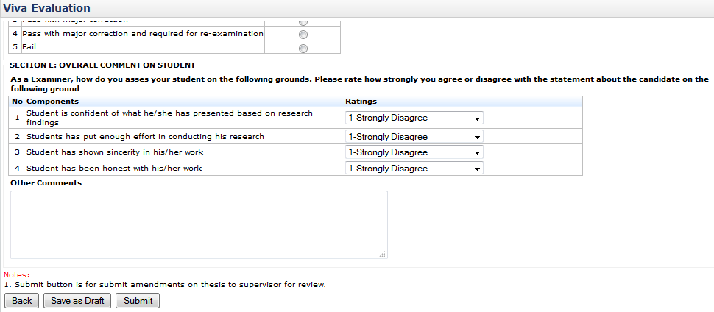

List of field need to be answer

Figure 60: Review Thesis

**Steps:-**

1. Click on **Add** button to proceed (refer figure 55)
2. This page will display every single detail that need to be answer same as report given in VIVA evaluation
3. To save the detail, click **Save as Draft.** (refer figure 59)
4. To submit evaluation report, click **Submit** button (refer figure 59)

## Review Amendment on Thesis

### Review Feedback from External Examiner

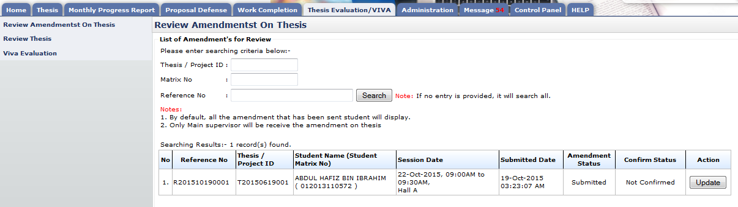

Figure 61: Review Feedback from External Examiner

**Pre-condition**

1. Student must submit thesis and verified by supervisor first
2. Review can be made after the date of VIVA evaluation
3. Student must submit amendment first.

**Post-condition**

1. Comment on amendment.
2. Amendment confirmation

**Steps:-**

1. Click on the **Thesis Evaluation/VIVA** tab on the **Top** panel
2. Click on the **Review Amendment On Thesis** menu on the **Left** panel
3. System will display list of amendment

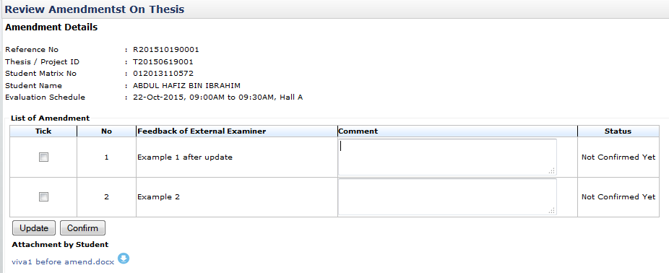

Space for comment the feedback

List of feedback of external examiner listed by student

Figure 62: Review Feedback of External Examiner

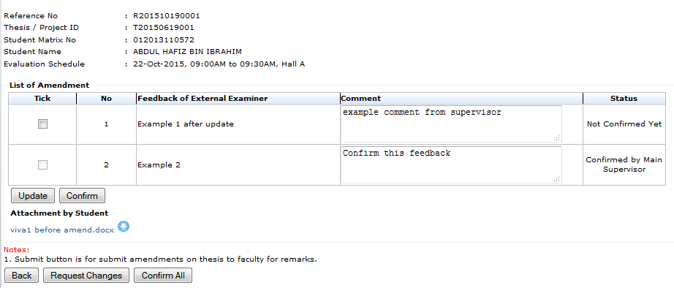

Figure 63: Review Feedback of External Examiner

**Steps:-**

1. To comment on each feedback of external examiner listed by student. Insert comment or remark into text field provided. Then tick the check box on the far left side of the table and click **Update** button. (refer figure 61 & figure 62)
2. To confirm the feedback of external examiner, tick the check box on the far left side of the table and click **Confirm** button (refer figure 61 & figure 62)
3. To download attachment attach by student, click on link shown like figure 62
4. To ask student for change the feedback, click **Request Changes.** (refer figure 62)
5. To confirm all the feedback listed and proceeds with amendment. Click **Confirm All** button.

### Review Amendment on Thesis

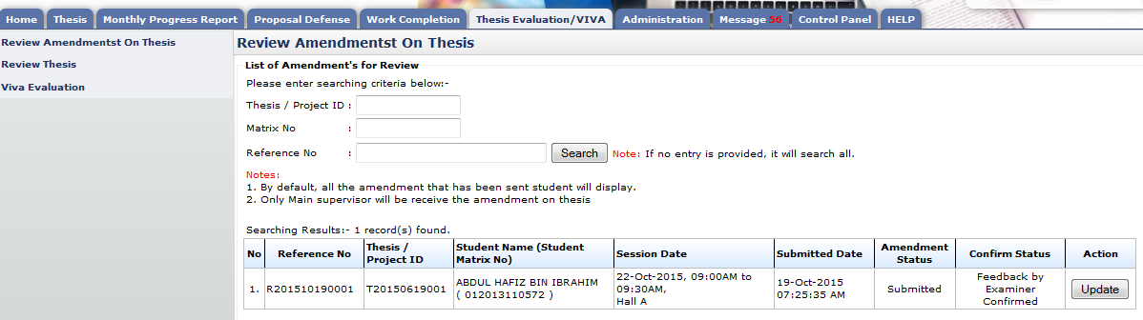

Figure 64: Review Amendment on Thesis

**Pre-condition**

1. Student must submit thesis and verified by supervisor first
2. Review can be made after the date of VIVA evaluation
3. Student must submit amendment first.
4. Feedback of external examiner must be confirmed by supervisor first

**Post-condition**

1. Comment on amendment.
2. Amendment confirmation

**Steps:-**

1. Click on the **Thesis Evaluation/VIVA** tab on the **Top** panel
2. Click on the **Review Amendment On Thesis** menu on the **Left** panel
3. System will display list of amendment

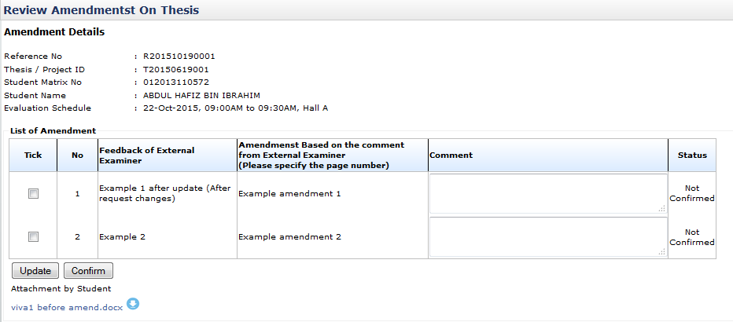

Space for comment the feedback

List of feedback of external examiner listed by student

Figure 65: Review Amendment on Thesis

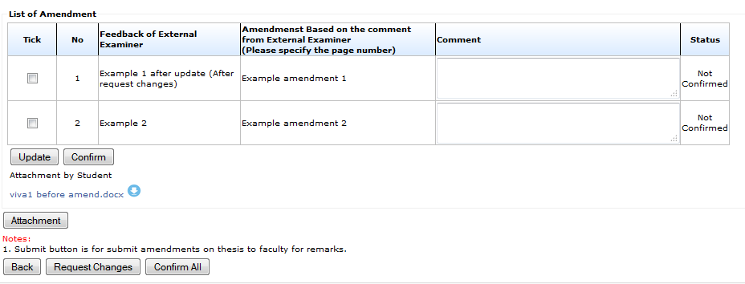

To upload attachment

Figure 66: Review Amendment on Thesis

**Steps:-**

1. To comment on each amendment listed by student. Insert comment or remark into text field provided. Then tick the check box on the far left side of the table and click **Update** button. (refer figure 64 & figure 65)
2. To confirm the amendment listed, tick the check box on the far left side of the table and click **Confirm** button (refer figure 64 & figure 65)
3. To download attachment uploaded by student, click on the link shown like figure 65
4. To upload attachment, click **Attachment** button(figure 65 and **Upload attachment**)
5. To request change amendment, click **Request Changes.** (refer figure 65)
6. To confirm all the amendment and forward to faculty. Click **Confirm All** button. (refer figure 65)

#### Upload attachment

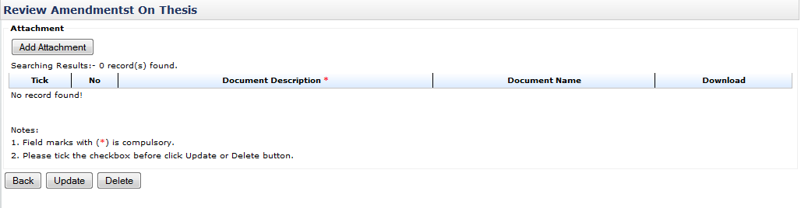

Add Attachment

Figure 67: Upload Attachment

**Post-condition**

1. Document Description can be update
2. Attachment can be deleted

**Steps:-**

1. To upload attachment/thesis click **Add Attachment** button (refer figure 66)
2. Then popup like figure 49 will appear and click **browse** button.
3. Choose necessary file for upload like figure 68 and click **Open** button.
4. After done choose file for upload. Insert file description and click **Insert Attachment** button to proceed.
5. Then click **Done** button (refer figure 70)
6. To change file and file description, click **Reset** button.
7. To stop from uploaded or close popup windows. Click **Exit** button or (**X**) windows button.

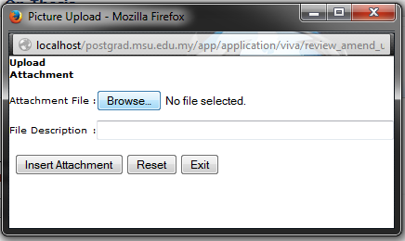

Figure 68: Upload Attachment

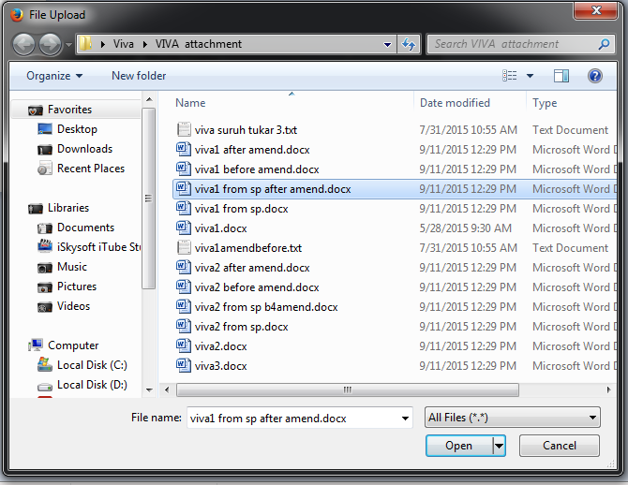

Figure 69: Upload Attachment

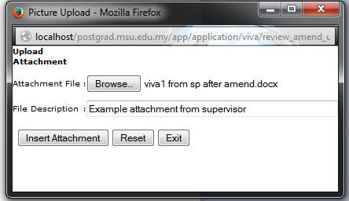

Figure 70: Upload Attachment

1. Continue from step 5, to update file/document description. Change the text inside text field provided. Then tick the checkbox placed on the far left side and click **Update** button. (refer figure 71)
2. To download file uploaded, click button. (refer figure 71)
3. To delete uploaded file, tick the checkbox on the far left side of the table and click **Delete** button afterward. (refer figure 71)
4. Figure 72 is example of picture indicate number of uploaded file
5. To upload another file, repeat step 1
6. To go back to previous pages. Click **Back** button.

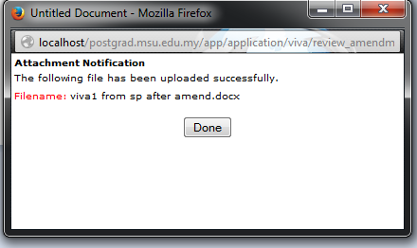

Figure 71: Upload Attachment

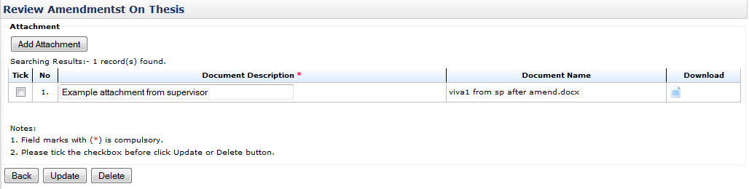

Figure 72: Upload Attachment



Figure 73: Indicate number of attachment uploaded

# Administration

## Staff Biodata

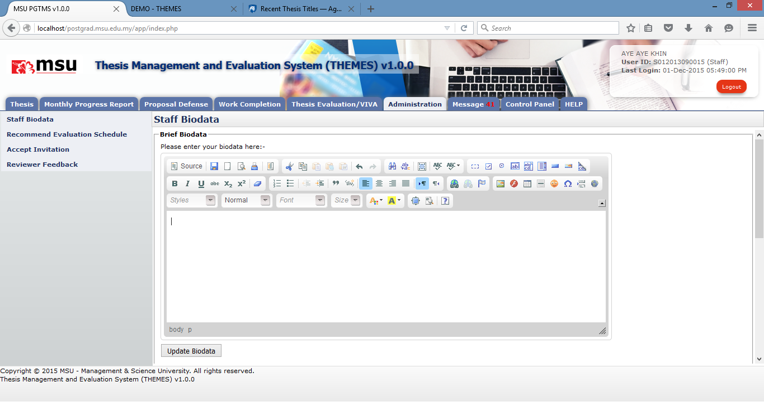

## Recommend Evaluation Schedule

### Recommend Evaluation Schedule

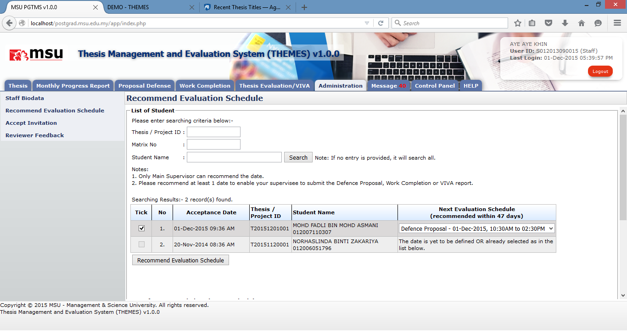

**Prerequisite**

The Faculty has scheduled the evaluation session i.e. Defence Proposal, Work Completion or VIVA for the selected Evaluation Panel

**Steps**

**Next Action**

None

**Warning**

None

**Note**

None

### Cancel Evaluation Schedule

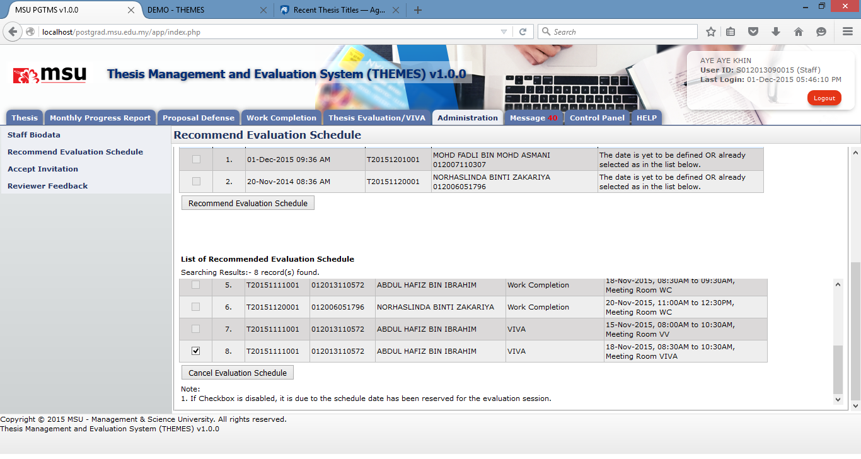

**Prerequisite**

The Faculty has scheduled the evaluation session i.e. Defence Proposal, Work Completion or VIVA for the selected Evaluation Panel

**Steps**

**Next Action**

None

**Warning**

None

**Note**

None

## Accept Invitation

### Supervisor/Co-Supervisor

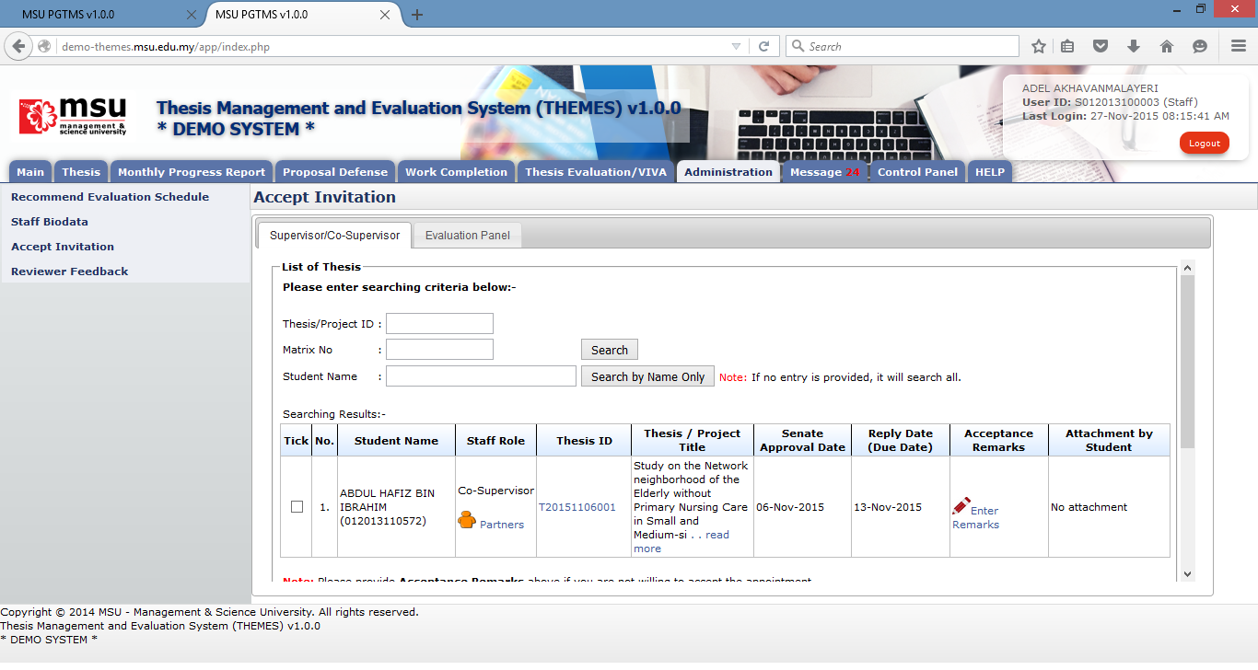

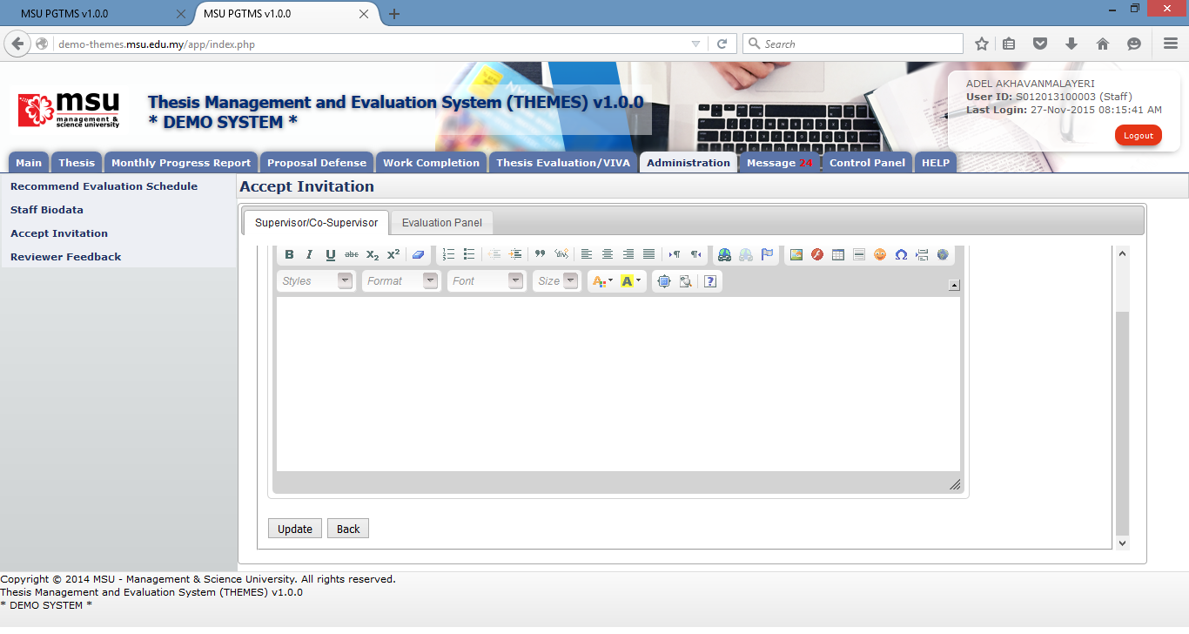

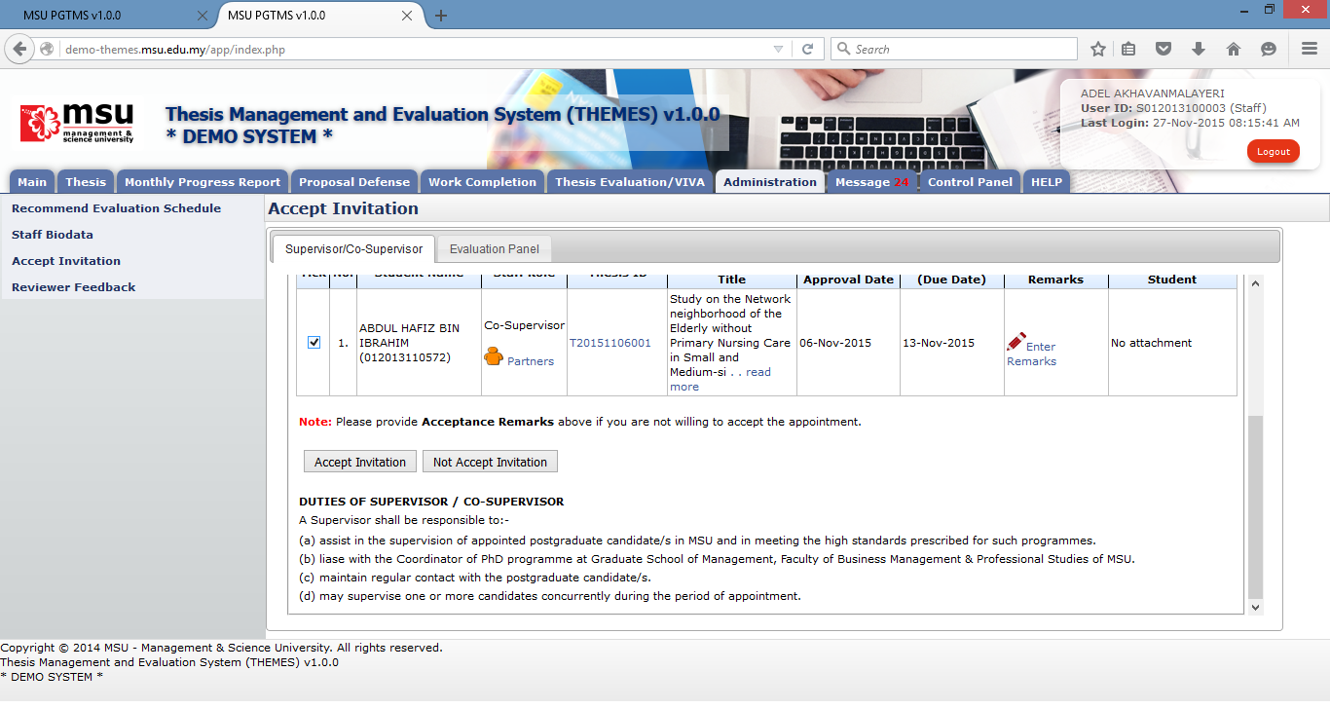

**Prerequisite**

The Faculty has scheduled the evaluation session i.e. Defence Proposal, Work Completion or VIVA for the selected Evaluation Panel

**Steps**

**Next Action**

None

**Warning**

None

**Note**

None

### Evaluation Panel

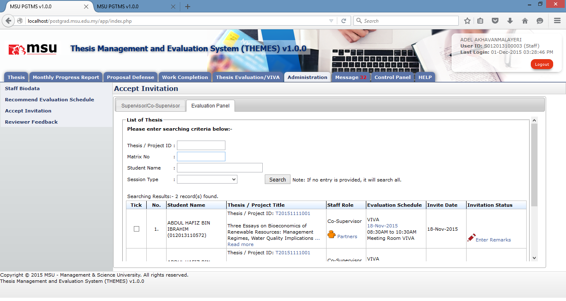

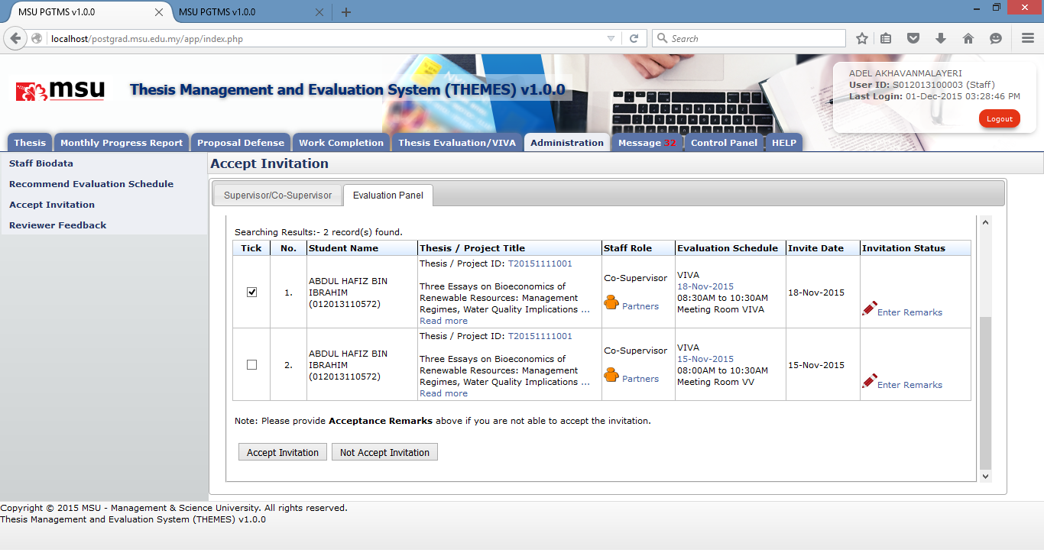

**Prerequisite**

The Faculty has scheduled the evaluation session i.e. Defence Proposal, Work Completion or VIVA for the selected Evaluation Panel

**Steps**

**Next Action**

None

**Warning**

None

**Note**

None

## Reviewer Feedback - NOK

Reviewer Feedback contain list of thesis that been assign by faculty to review.

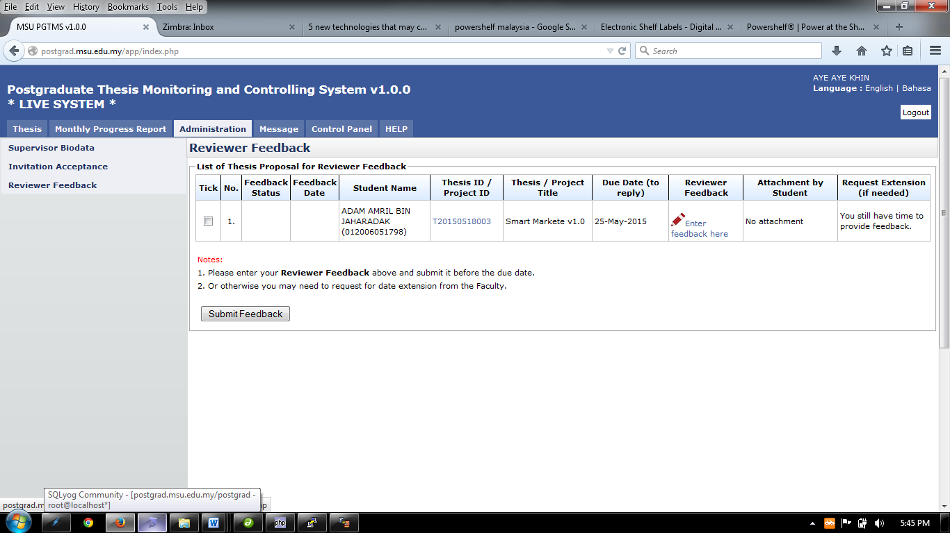

Figure 23: Reviewer Feedback

**Pre-condition**

1. Faculty assign reviewer

**Post-condition**

1. Wait for other thesis proposal for review.

**Steps:-**

1. Click on the **Administration** tab on the system **Top** panel section.
2. The **Administration** menu will be displayed on the system **Left** panel and click on it.
3. 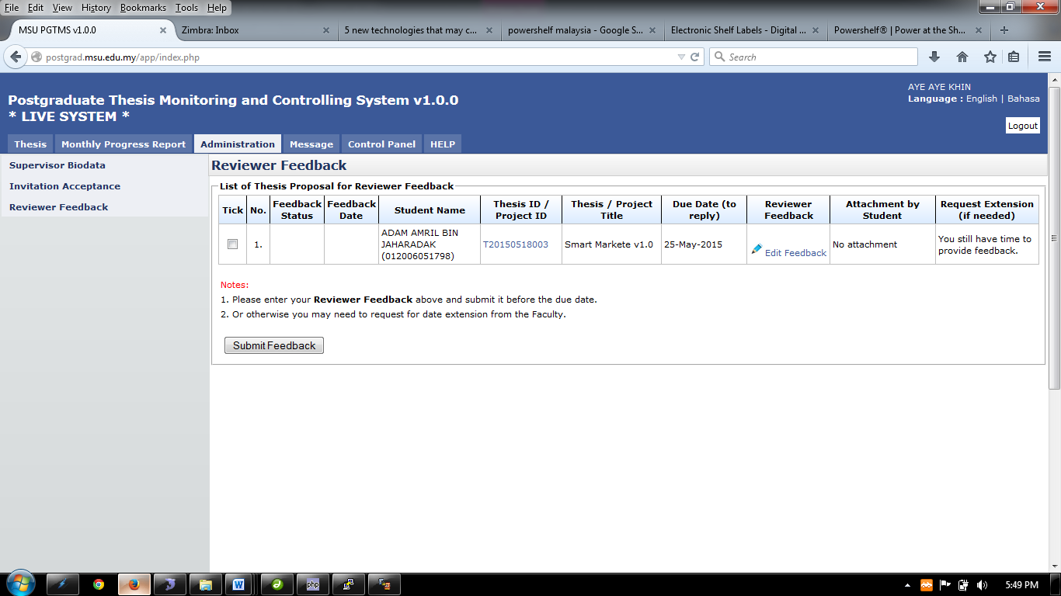Click the **Reviewer Feedback** and the list of thesis proposal for reviewer feedback will be display..
4. To give the feedback or read the feedback or edit feedback, click on the link  (Refer 8.1: Enter Feedback)
5. To View Thesis Detail, Click on Thesis ID. (Refer 8.2: Thesis Detail)

### Enter Feedback

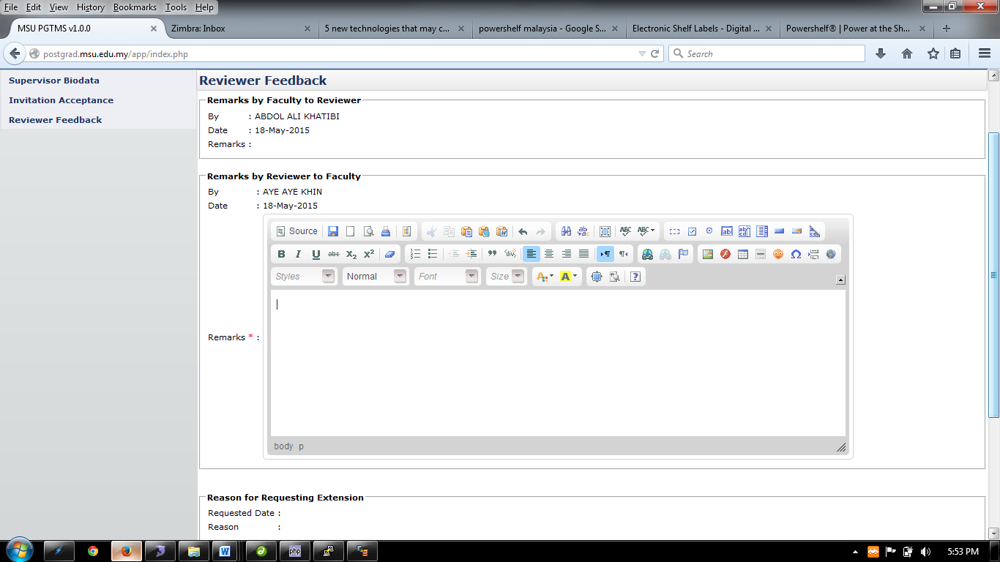

Figure 24: Enter Feedback

**Steps:-**

1. Enter necessary feedback and click **Update** button.
2. To go back to the previous page, click **Back** button

### Thesis Detail

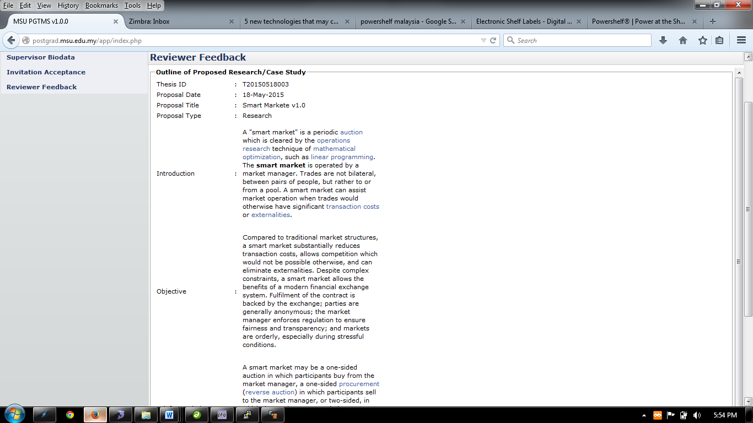

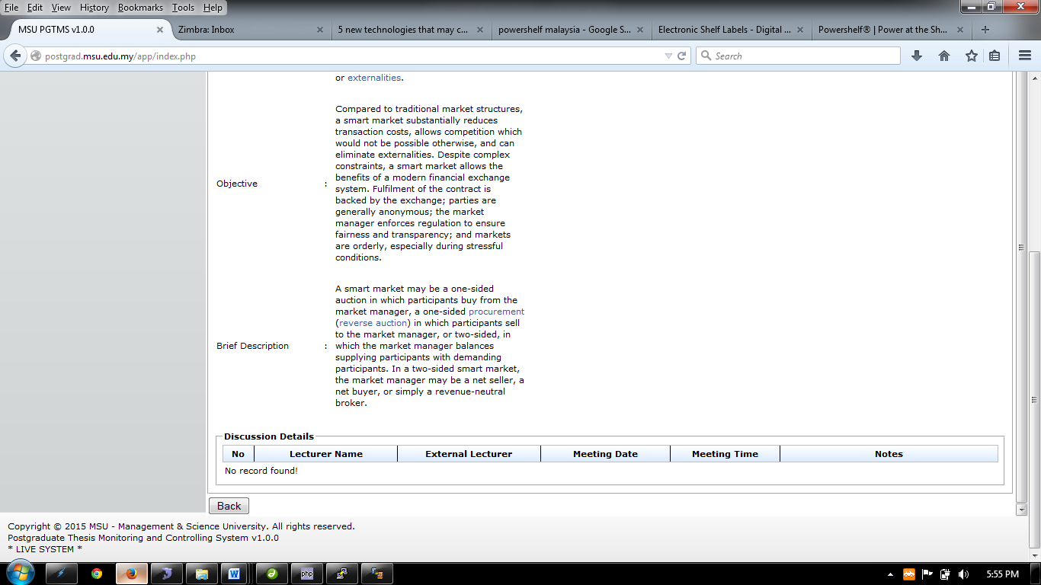

Figure 25: Thesis Detail

**Steps:-**

1. This page only display the thesis detail
2. Click **Back** button to go to previous page.

### Submit Feedback

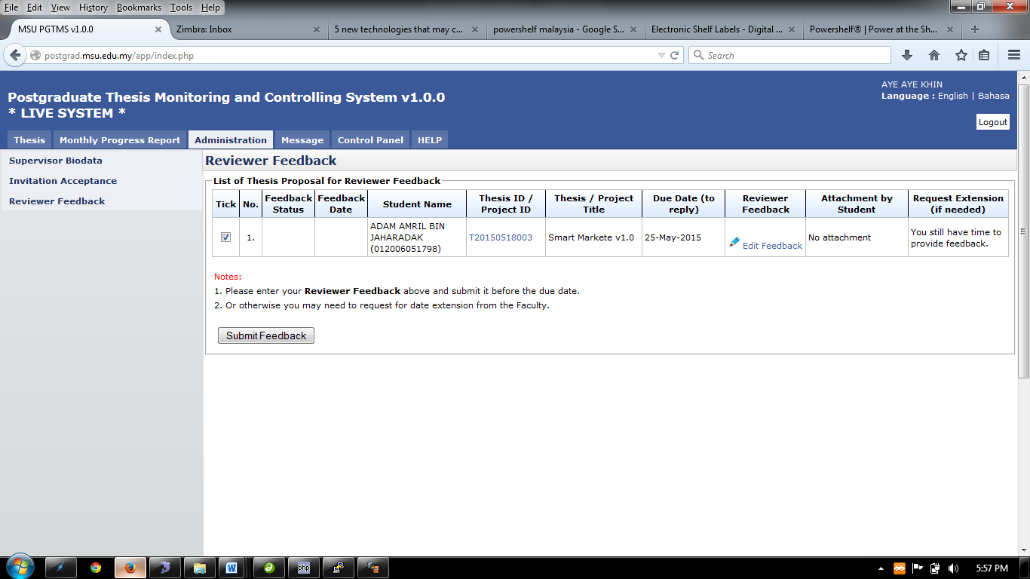

Figure 26: Feedback Submission

**Steps:-**

1. Tick the checkbox and click **Submit Feedback** button to proceed.

# Message

## Inbox

### New and Read Message

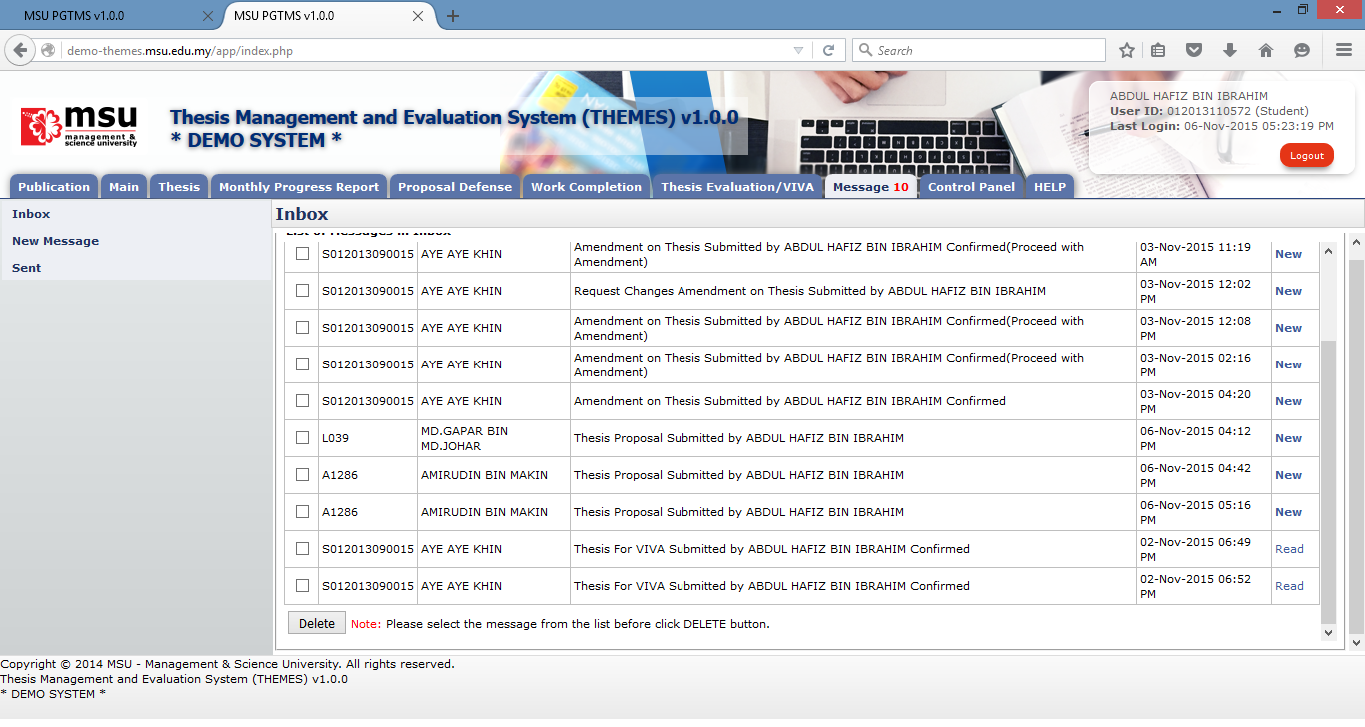

**3**

**2**

**1**

Figure 39: Message

**Prerequisite**

None

**Steps**

1. Click on the **Message** tab on the **Top** panel. If there is a number with it, that’s mean there are unread messages available pending action from the student.
2. Click on the **Inbox** menu on the **Left** panel. System will display the list of message on the **Working Area** section.
3. On the far right side, it will display the status of the message whether is **New** or **Read.** To read the message, click on it.
4. To delete message, tick on the checkbox in **Tick** column, and click **Delete** button

**Next Action**

None

**Warning**

None

**Note**

None.

### Delete Message



**4**

**3**

**2**

**1**

Figure 40: Delete Message

**Prerequisite**

None

**Steps**

1. Click on the **Message** tab on the **Top** panel. If there is a number with it, that’s mean there are unread messages available pending action from the student.
2. Click on the **Inbox** menu on the **Left** panel. System will display the list of message on the **Working Area** section.
3. Tick the checkbox in which the message is going to be deleted. It can be done in multiple rows.
4. Click on the **Delete** button to delete the message from the list.

**Next Action**

None

**Warning**

System will prompt a notification message if the checkbox is untick before the deletion.

**Note**

None

## New Message

### Send Message

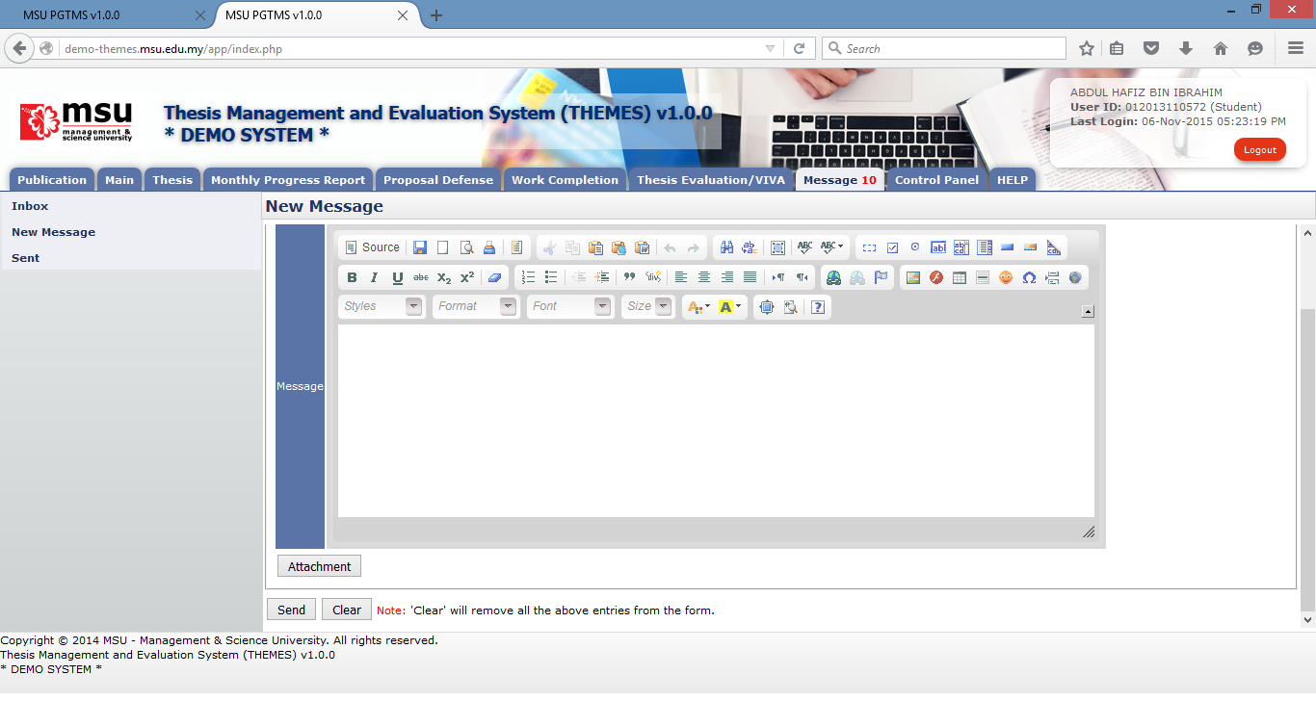

**3**

**2**

**1**

Figure 41: New Message

**Prerequisite**

None

**Steps**

1. Click on the **Message** tab on the **Top** panel
2. Click on the **New Message** menu on the **Left** panel
3. Once the Recipient, the message and the attachment (if any) are in place, then click **Send** button to send it to the Recipient.

**Next Action**

None

**Warning**

System will prompt a notification message if the checkbox is unticking before the deletion.

**Note**

None

### Select Recipient

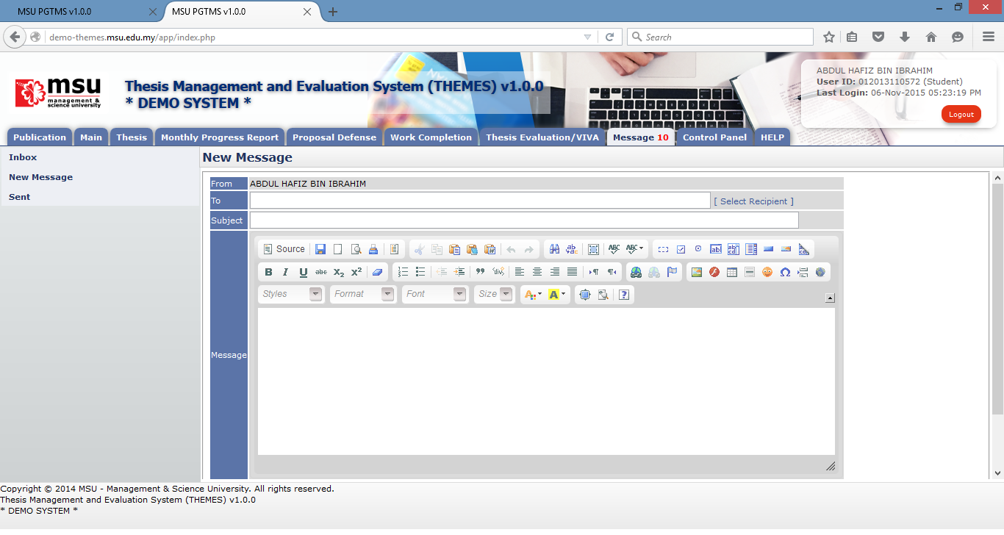

**1**

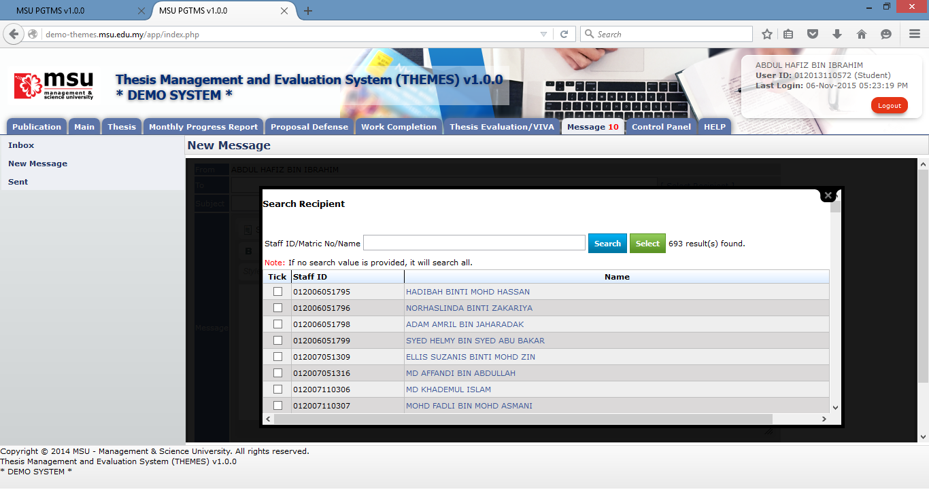

**4**

**2**

**3**

Figure 42: Select Recipient

**Prerequisite**

None

**Steps**

1. Click on the **Select Recipient** link to open the Recipient List page.
2. Enter the searching criteria and click **Search** button to search the specific search result or just click the **Search** button to search the general result.
3. Tick on the checkbox for the identified recipient.
4. Click on the **Select** button to populate the selected recipient into the **To** field on the New Message page.

**Next Action**

None

**Warning**

None

**Note**

None

### Upload Attachment - Add



**1**

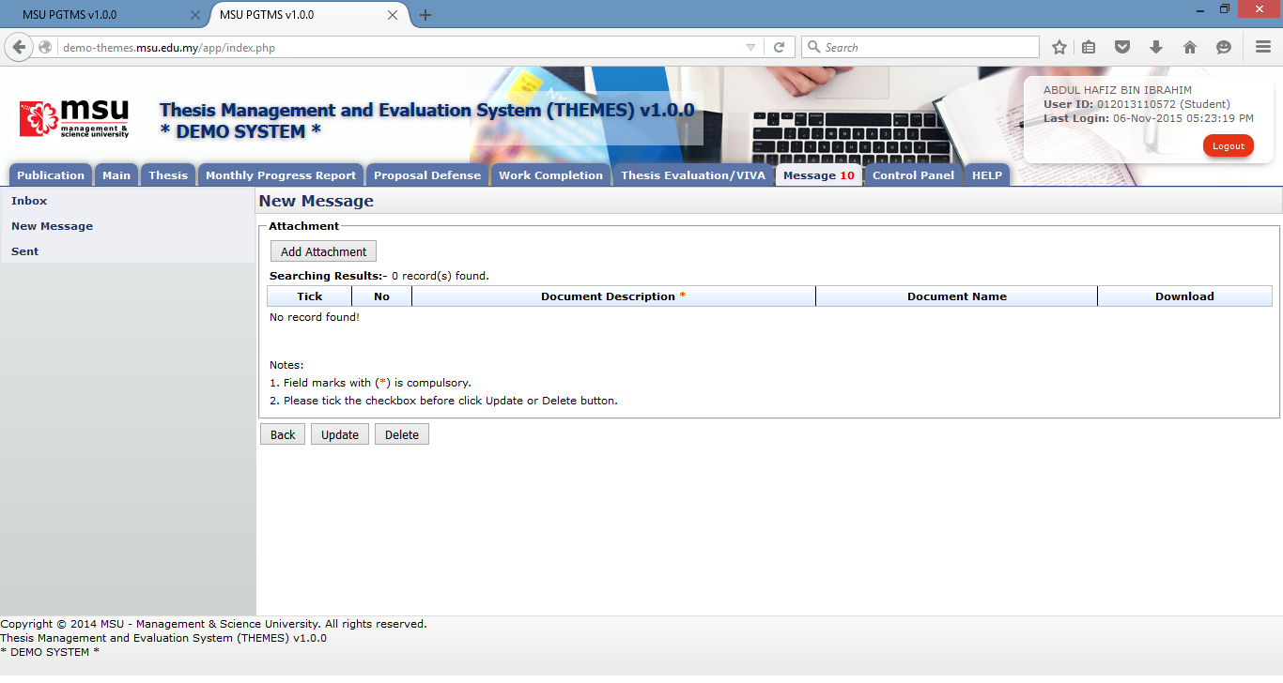

**2**

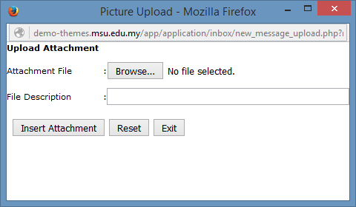

**4**

**3**

Figure 43: Upload Attachment - Add

**Prerequisite**

None

**Steps**

1. Click on the **Attachment** button to open the Attachment page.
2. On Attachment page, click on the **Add Attachment** button.
3. Click on the **Browse** button to select the attachment. File Description field is optional.
4. Click on the **Insert Attachment** button to add the select attachment into the attachment list.

**Next Action**

1. Send the message
2. Update the attachment’s description
3. Delete the attachment

**Warning**

None

**Note**

None

### Upload Attachment - Update

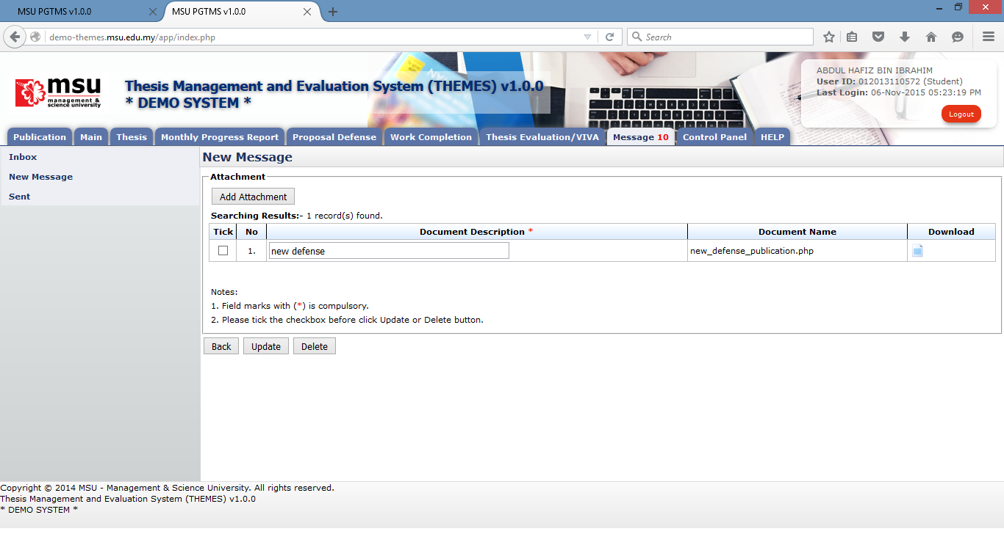

**3**

**1**

**2**

Figure 44: Upload Attachment - Update

**Prerequisite**

The attachment has been added into the attachment list.

**Steps**

1. Update the document’s description. It can be done in multiple rows.
2. Tick the checkbox for the document’s description being updated. It can be done in multiple rows.
3. Click on the **Update** button to update the changes.

**Next Action**

1. Send the message
2. Update the attachment’s description
3. Delete the attachment

**Warning**

None

**Note**

None

### Upload Attachment - Delete



**1**

**2**

Figure 45: Upload Attachment - Delete

**Prerequisite**

The attachment has been added into the attachment list.

**Steps**

1. Tick the checkbox for the document to be deleted. It can be done in multiple rows.
2. Click on the **Delete** button to delete the attachment from the list.

**Next Action**

1. Send the message
2. Add other new attachment
3. Delete other attachment

**Warning**

None

**Note**

None

## Sent Message

### View Sent Message

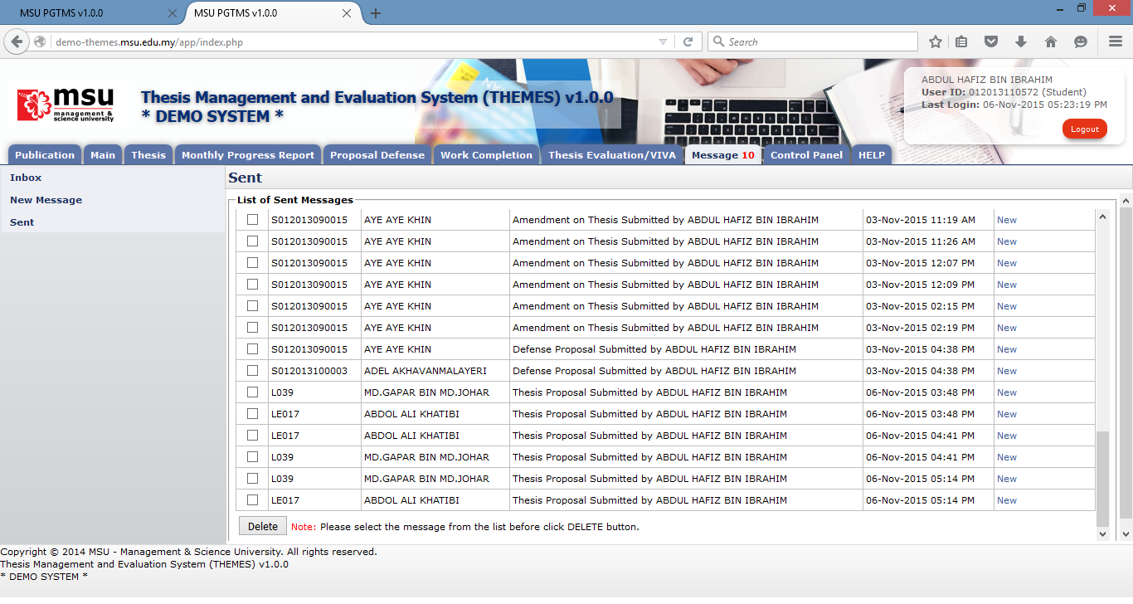

**1**

**3**

**2**

Figure 46: View Sent Message

**Prerequisite**

The message has been sent to the Recipient.

**Steps**

1. Click on the **Message** tab on the **Top Panel**.
2. Click on the **Sent** menu on the **Left Panel**.
3. To view the sent message, click on the message status

**Next Action**

None

**Warning**

None

**Note**

None

### Delete Sent Message



**3**

**1**

**4**

**2**

Figure 47: Delete Sent Message

**Prerequisite**

The message has been sent to the Recipient.

**Steps**

1. Click on the **Message** tab on the **Top Panel**.
2. Click on the **Sent** menu on the **Left Panel**.
3. Tick the checkbox for which the messages need to be deleted. It can be done in multiple rows.
4. Click on the Delete button to delete the messages from the list.

**Next Action**

None

**Warning**

None

**Note**

None

# Control Panel

## Change Password

### Before Login



**1**

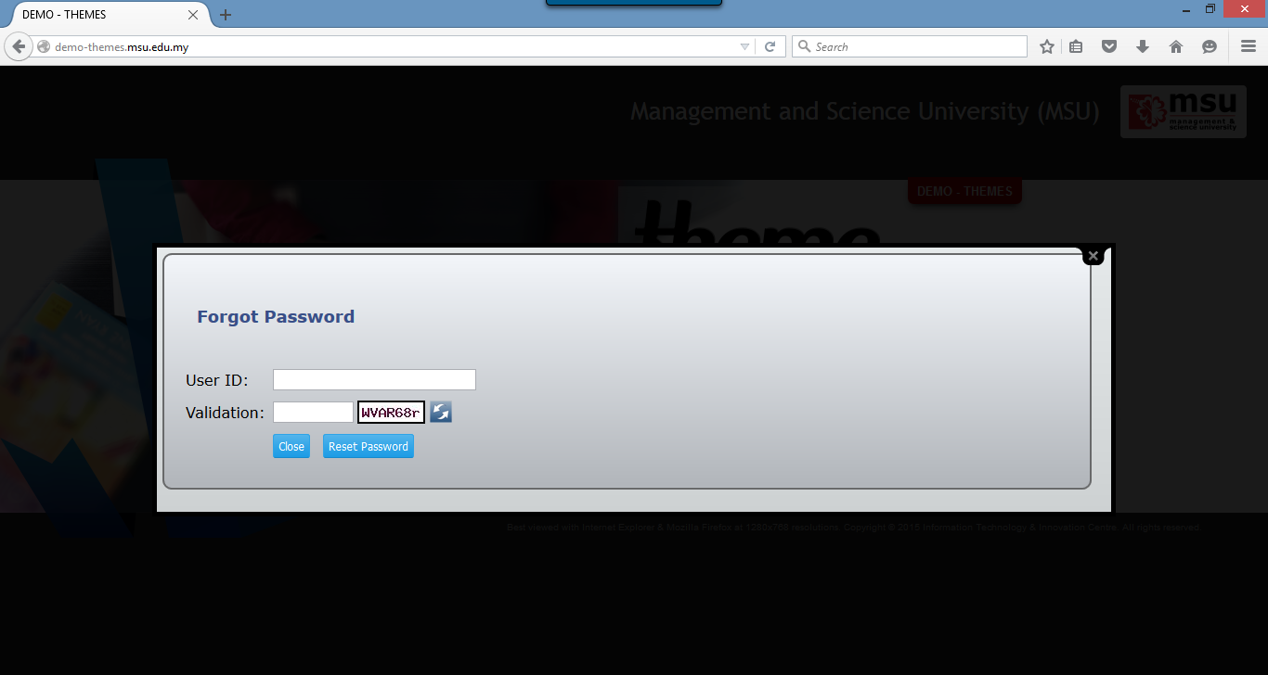

**3**

**2**

Figure 48: Change Password Page Before Login

**Prerequisite**

The User must have the email ID registered in KLAS2 system which failure to provide the valid email ID causing the system to do not generate and email a new reset password.

**Steps**

1. Click on the **Forgot Your Password** at the Login Page. The **Forgot Password** page will be displayed
2. Enter your **User ID** and **Validation Code**. The Validation Code can be refreshed if you want to change it.
3. Click on the **Reset Password** button. The system will generate the new password and send it to the registered user’s email ID.

**Warning**

System will prompt a message if no email ID found in KLAS2 system. The User needs to register it in KLAS2 first before request to reset the password.

**Note**

None.

### After Login

For the security reason, the user is strongly recommended to change the password at first successful login to the system.

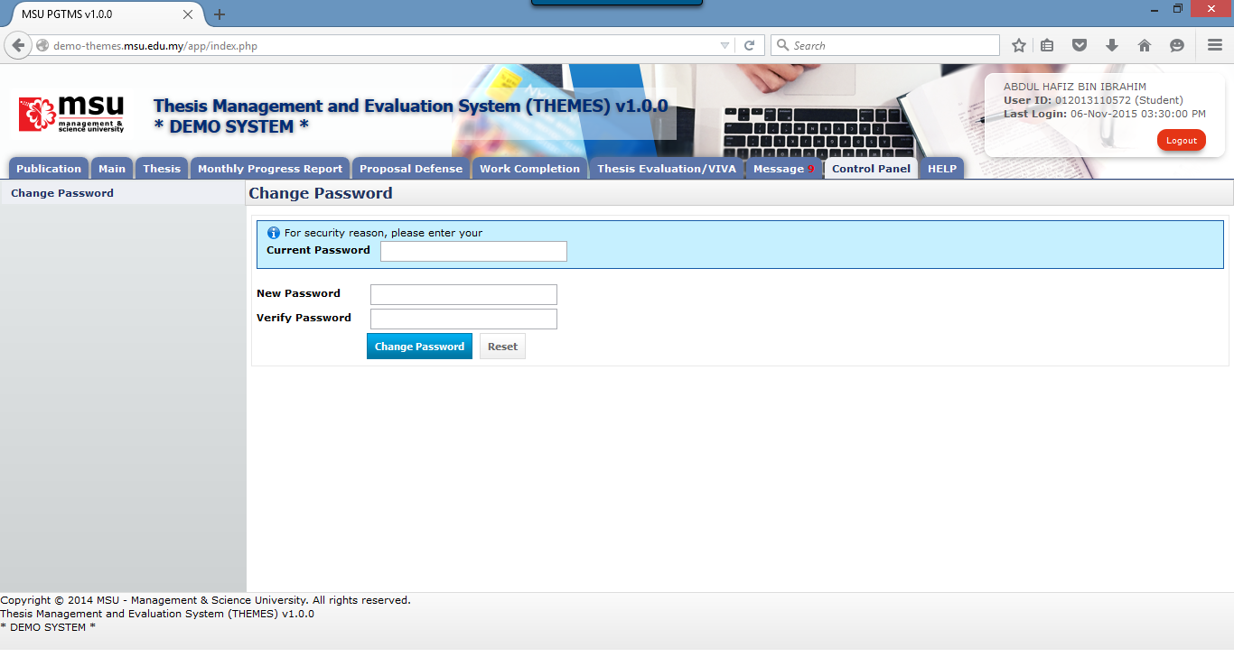

**6**

**5**

**4**

**3**

**2**

**1**

Figure 49: Change Password Page After Login

**Prerequisite**

None

**Steps**

1. Click on the **Control Panel** tab from the system **Top** panel section.
2. The **Change Password** menu will be displayed and click on it.
3. As security measure, the system will ask **Current Password** from the user.
4. Then follow by the **New Password** and **Verify Password**.
5. Click **Change Password** button to save the newly change password into the system successfully.
6. User can use **Reset** button if wanted to clear the entry on each fields.

**Warning**

1. If the provided **Current Password** is incorrect, the system will prompt an error message and the user needs to redo the above step 3 onwards.
2. If the provided **New Password** and **Verify Password** are mismatched, the system will prompt an error message and the user needs to provide the match password for both.
3. The user cannot reuse the last 3 passwords which have been used before.
4. The password shall have the numeric (0-9) and characters (a-z, A-Z)

**Note**

None.

# Help

## Online Help - Student

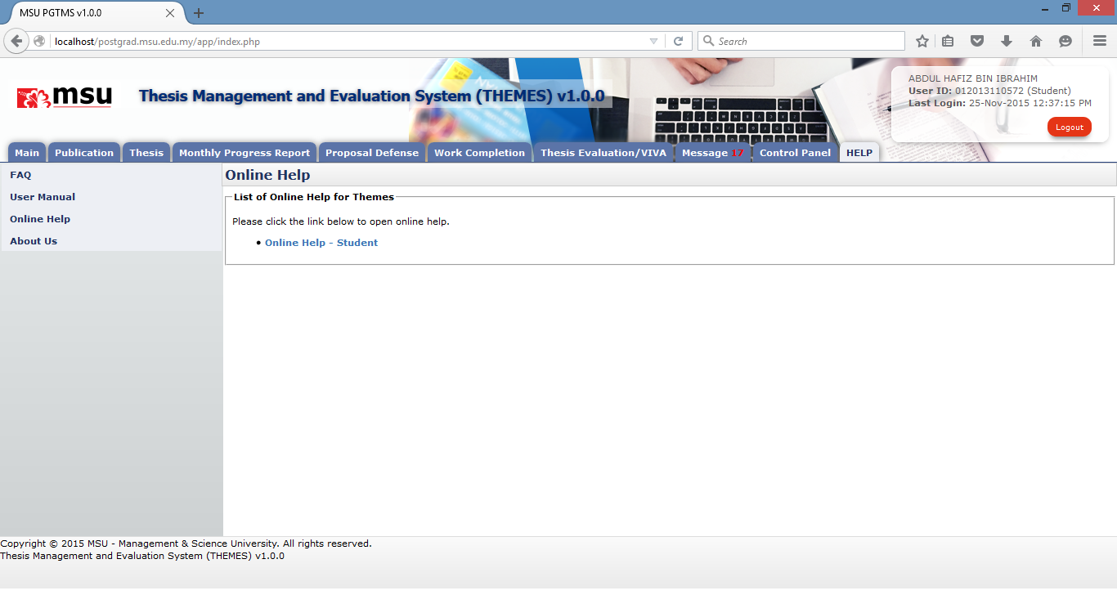

**2**

**3**

**1**

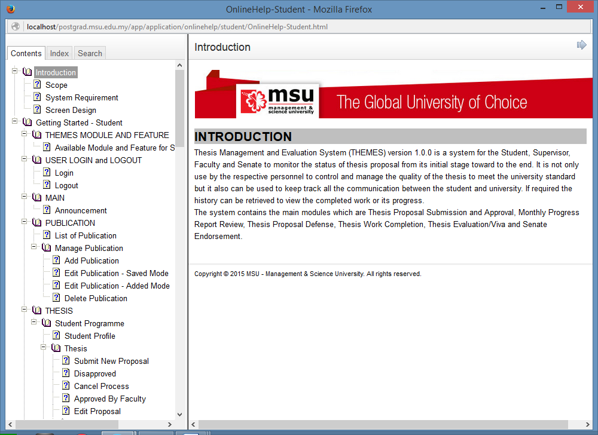

**4**

Figure 58: Online Help

**Prerequisite**

None

**Steps**

1. Click on the **HELP** tab from the system **Top** **Panel** section.
2. Click on the **Online Help** on the **Left Panel** section.
3. The online help will be displayed on the **Working Area** section which listed the applicable help to the Student. Click on the online help link.
4. The Online Help page will be displayed. The student can browse through the content to find the required help.

**Next Action**

None

**Warning**

None

**Note**

None.

## User Manual

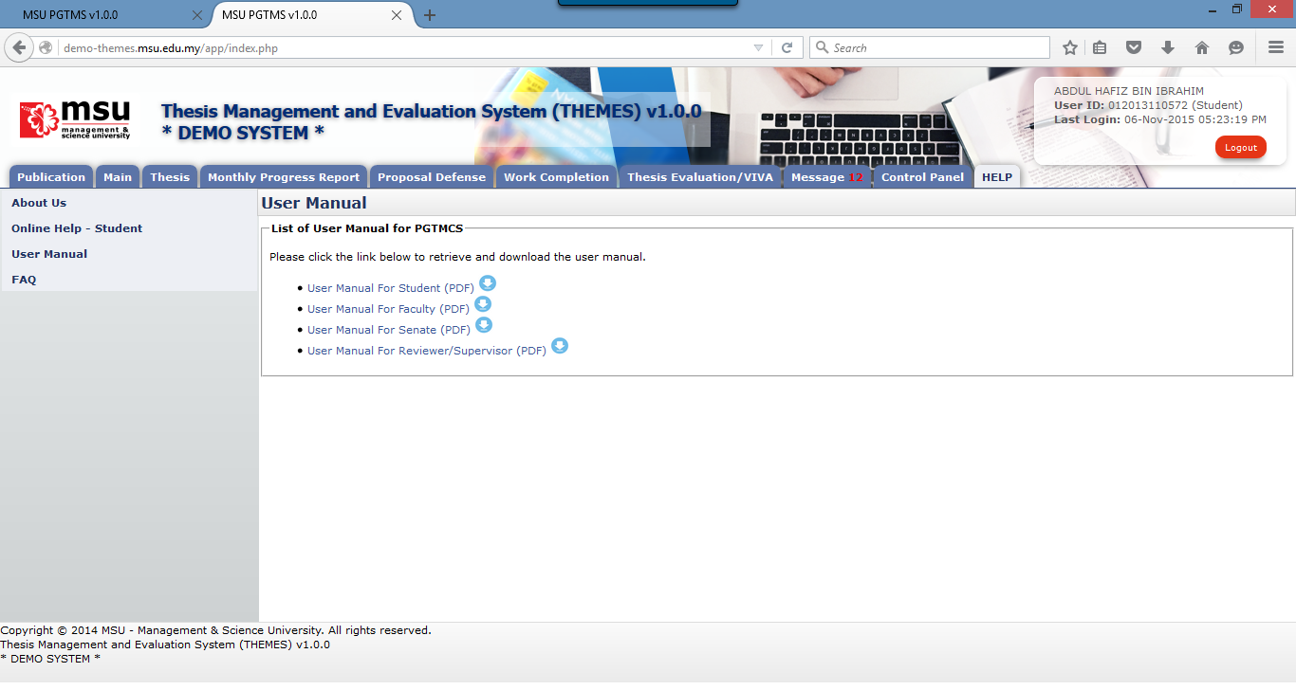

**3**

**2**

**1**

Figure 59: User Manual

**Prerequisite**

None

**Steps**

1. Click on the **Help** tab on the **Top** panel
2. Click on the **User Manual** menu on the **Left** panel
3. System will display the link to download user manual on the **Working Area** section.

**Next Action**

None

**Warning**

None

**Note**

None.

## Frequently Asked Question

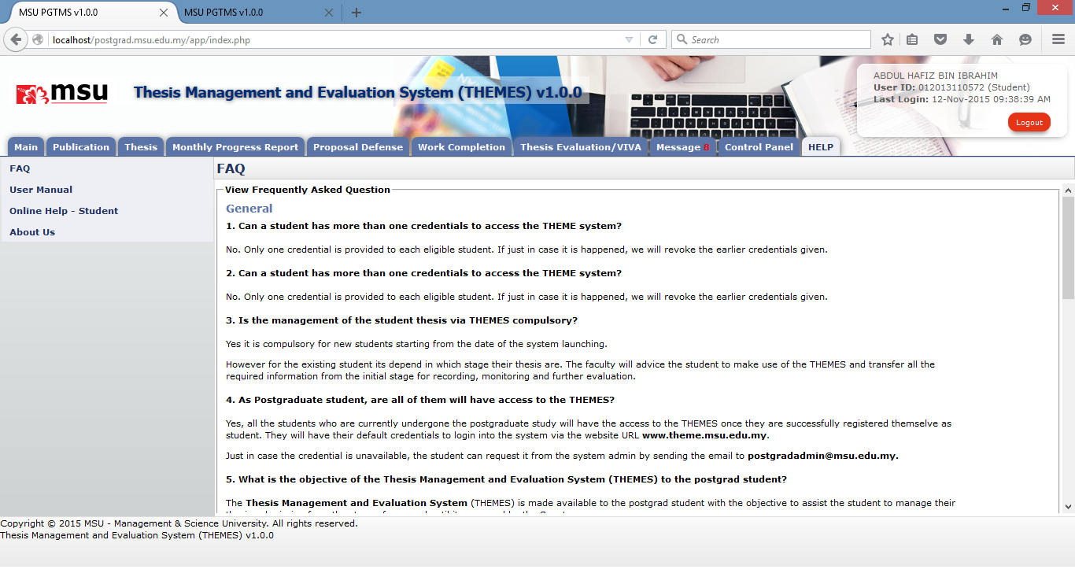

**2**

**1**

Figure 60: FAQ

**Prerequisite**

None

**Steps**

1. Click on the **Help** tab on the **Top** panel
2. Click on the **FAQ** menu on the **Left** panel
3. System will display the list of FAQ on the **Working Area** section.

**Next Action**

None

**Warning**

None

**Note**

None

## About Us

The page where indicate the current system’s version and email to send comment and report bugs.

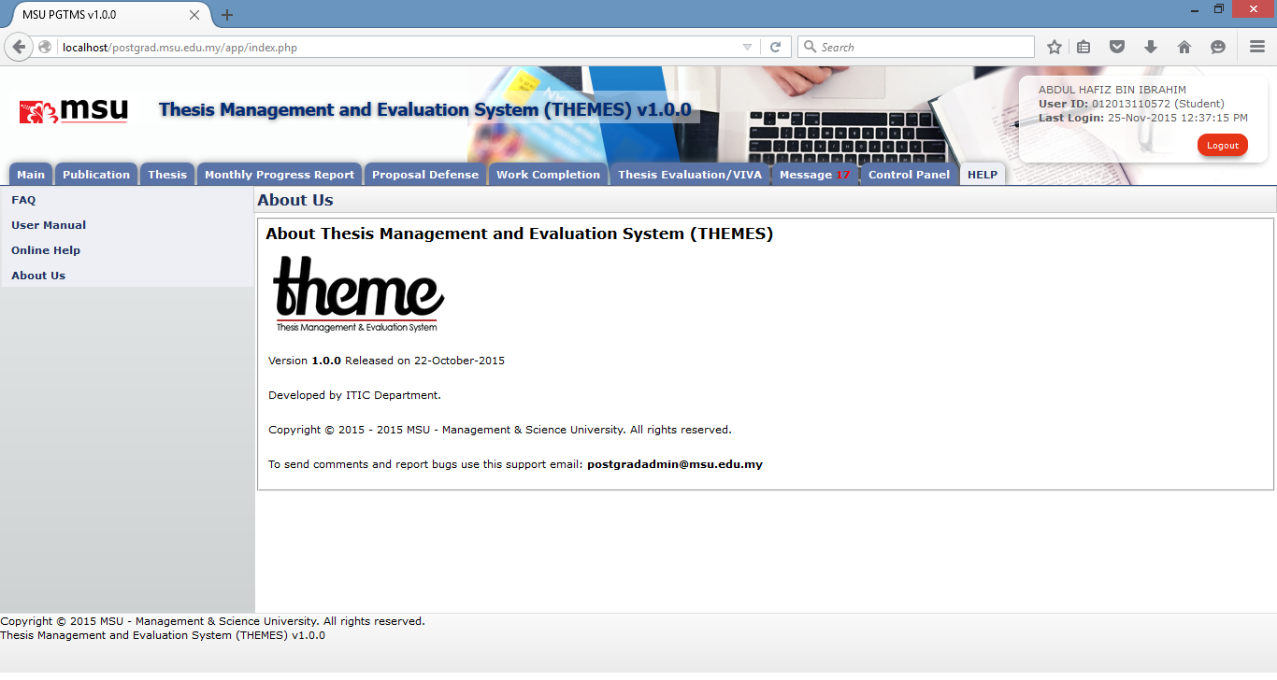

**3**

**2**

**1**

**Prerequisite**

None

**Steps**

1. Click on the **Help** tab on the **Top** panel
2. Click on the **About Us** menu on the **Left** panel
3. System will display the About Us information on the **Working Area** section.

**Next Action**

None

**Warning**

None

**Note**

None.

This page is intentionally left blank.